Business Process Analysis Worksheets & Guidelines v1.0


Business Process Team
10 May 2001

Procedures for developing business processes in ebXML

Status of this Document
This Technical Report document has been approved by the ebXML Business Process Project Team and has been accepted by the ebXML Plenary. This document contains information to guide in the interpretation or implementation of ebXML concepts.
Distribution of this document is unlimited.
The document formatting is based on the Internet Society’s Standard RFC format.
This version:
http://www.ebxml.org/specs/bpWS.pdf
Latest version:
http://www.ebxml.org/specs/bpWS.pdf

ebXML participants
Business Process Project Team Co-Leads
Paul Levine, Telcordia
Marcia McLure, McLure-Moynihan, Inc.
We would like to recognize the following for their significant participation to the development of this document.
Editors
Charles Fineman, Arzoon.
Brian Hayes, Commerce One.
Jennifer Loveridge, Nordstrom.com.
William E. McCarthy, Michigan State University
David Welsh, Nordstrom.com.
Contributors
Jim Clark, International Center of Object Technology.
Randy Clark, Baker Hughes, Inc.
Bob Haugen, Logistical Software.
Larissa Leybovich, Vitria
Nita Sharma, Netfish Technologies.

Table of Contents
1. Status of this Document 2
2. ebXML participants 3
3. Table of Contents 4
4. Introduction 7
4.1. Summary 7
4.2. Audience 8
4.3. Related Documents 8
4.4. Document Conventions 9
5. Design Objectives 10
5.1. Goals/Objectives/Requirements/Problem Description 10
5.2. The Analogy 12
5.3. Caveats and Assumptions 12
6. Worksheet Based Analysis Overview 13
6.1. Basic Guidelines for filling out Worksheets 14
6.1.1 Focus on public Business Processes 14
6.1.2 The REA Ontology 14
6.1.3 Use the worksheets in the order that makes the most sense for you 14
6.1.4 The worksheets can be used for projects of various scopes 14
6.1.5 Think how will people use what you construct 15
6.1.6 Re-use is one of the primary goals of ebXML 15
6.1.7 Note on optional fields in the worksheets 15
6.1.8 Number your worksheets 16
6.2. Worksheets to Metamodel Mapping 16
7. Business Process Identification and Discovery 18
7.1. Goals 18
7.2. Guidelines 19
7.2.1 How does one decide how big to make the various groupings at this level? 19
7.2.2 What is the boundary of the business area? 19
7.3. Worksheets 20
7.3.1 Business Reference Model 20
7.3.2 Business Area 21
7.3.3 Process Area 22
7.3.4 Identify Business Processes 23
8. Business Process Elaboration 23
8.1. Goals 23
8.2. Worksheet 24
9. Economic Elements 26
9.1. Goals 26
9.2. Guidelines 26
9.3. Worksheets 27
10. Business Collaboration 29
10.1. Goals 29
10.2. Worksheets 30
11. Business Transactions and Authorized Roles 32
11.1. Goals 32
11.2. Guidelines 32
11.2.1 Use Transaction Patterns 32
11.2.2 Detail Transaction Activities Only If Necessary 32
11.3. Worksheets 33
12. Business Information Description 35
12.1. Goals 35
Guidelines 35
12.3. Worksheets 35
12.3.1 Business Information Context 35
12.3.2 Document Content Description 38
12.3.3 Content Mapping 38
Appendix A Business Process Identifier Naming Scheme 40
Appendix B The Porter Value Chain 42
Appendix C Drop Ship Scenario Example 44
C.1 Business Process Identification and Discovery: BRM-1.0-Direct-To-Customer-Drop-Ship-Retail-Model 47
C.1.1 Business Areas 49
C.1.1.1 BA-2.0-Direct-to-Customer-Retail 49
C.1.1.2 BA-2.1-Finacial 50
C.1.2 Direct To Customer Retail Process Areas 51
C.1.2.1 PA-3.1-Customer-Order-Management 51
C.1.2.2 PA-3.2-Customer-Order-Fulfillment 53
C.1.2.3 PA-3.3-Vendor-Inventory-Management 54
C.1.2.4 PA-3.4-Product-Catalog-Exchange 55
C.1.3 Financial Process Areas 56
C.1.3.1 PA-3.5-Payment 56
C.1.4 Customer-Order-Management Business Process Summaries 56
C.1.4.1 BPS-4.1-Firm-Sales-Order 56
C.1.4.2 BPS-4.2-Customer-Credit-Inquiry 57
C.1.4.3 BPS-4.3-Customer-Credit-Payment 57
C.1.5 Customer Order Fulfillment Business Process Summaries 58
C.1.5.1 BPS-4.4-Purchase-Order-Management 58
C.1.5.2 BPS-4.5-Ship-Goods 58
C.1.6 Vendor Inventory Management Processes Summaries 58
C.1.6.1 BPS-4.6-Inventory-Management 58
C.1.7 Product Catalog Exchange Business Processes Summaries 59
C.1.7.1 BPS-4.7-Sales-Product-Notification 59
C.1.8 Payment Business Process Summaries 59
C.1.8.1 BPS-4.8-Invoice-Presentment 59
C.2 Business Process Elaboration 60
C.2.1 BPUC-5.1-Firm-Sales-Order 60
C.2.2 BPUC-5.2-Customer-Credit-Inquiry 62
C.2.3 BPUC-5.3-Customer-Credit-Payment 64
C.2.4 BPUC-5.4-Purchase-Order-Management 65
C.2.5 BPUC-5.5-Ship-Goods 66
C.2.6 BPUC-5.6-Inventory-Management 67
C.2.7 BPUC-5.7-Sales-Product-Notification 68
C.2.8 BPUC-5.8-Present-Invoice 68
C.3 Business Collaboration and Economic Events 70
C.3.1 BC-6.1-Create-Customer-Order 70
C.3.2 BC-6.2-Check-Customer-Credit 72
C.3.3 BC-6.3-Process-Credit- Payment 74
C.3.4 BC-6.4-Create-Vendor-Purchase-Order 76
C.3.5 BC-6.5-Shipment-Instruction 78
C.3.6 BC-6.6-Confirm-Shipment 80
C.3.7 BC-6.7-Vendor-Inventory-Reporting 82
C.3.8 BC-6.8-Request-Inventory-Report 84
C.3.9 BC-6.9-Sales-Product-Offering 85
C.3.10 BC-6.10-Invoice-Presentment 87
C.4 Business Transactions and Authorized Roles 89
C.4.1 BT-8.1-Firm-Customer-Sales-Order 89
C.4.2 BT-8.2-Check Customer Credit 90
C.4.3 BT-8.3-Charge-Customer-Credit 91
C.4.4 BT-8.4-Create-Vendor-Purchase-Order 93
C.4.5 BT-8.5-Vendor-Inventory-Report 95
C.4.6 BT-8.6-Request-Inventory-Report 97
C.4.7 BT-8.7-Shipment-Notification 99
C.4.8 BT-8.8-Confirm-Shipment 101
C.4.9 BT-8.9-Product-Offering 103
C.4.10 BT-8.10-Present-Invoice 105
C.5 Business Information Description 107
C.5.1 Purchase Order 107
C.5.1.1 Purchase Order Business Information Context 107
C.5.1.2 CD-9.1-Order 108
C.5.1.3 CD-#.#-Order-Summary 108
C.5.2 Content Mapping 110
C.5.2.1 CM-11.1-Order-Summary 110
Appendix D Disclaimer 112
Appendix E Contact Information 112

Figures
Figure 5-1, Worksheets Architectural Context 11
Figure 6-1 Overview of mapping from Worksheets to Metamodel 13
Figure 7-1 Business Process Identification and Discovery Worksheet to Metamodel Mapping 18
Figure 8-1 Mapping from business processes to the BRV 23
Figure 10-1 Mapping from Business Collaboration to BRV 29
Figure 12-1, Direct To Customer Retail Transaction and Physical Goods Flow Overview 47
Figure 12-2, <<BusinessOperationsMap>>Direct To Customer Drop Ship Retail 48
Figure 12-3, <<BusinessArea>>Direct to Customer Retail 50
Figure 12-4, <<BusinessArea>> Finance 51
Figure 12-5, <<ProcessArea>>Customer Order Management 52
Figure 12-6, <<ProcessArea>>Customer Order Fulfillment 53
Figure 12-7, <<ProcessArea>>Vendor Inventory Management 54
Figure 12-8, <<ProcessArea>>Product Catalog Exchange 55
Figure 12-9, <<ProcessArea>> Payment 56
Figure 12-13, <<BusinessCollaborationProtocol>> CreateCustomerOrder 71
Figure 12-14, <<BusinessCollaborationProtocol>> CheckCustomerCredit 73
Figure 12-15, <<BusinessCollaborationProtocol>> ProcessCreditPayment 75
Figure 12-16 , <<BusinessCollaborationProtocol>> CreateVendorPurchaseOrder 77
Figure 12-17, <<BusinessCollaborationProtocol>> ShipmentInstruction 79
Figure 12-18, <<BusinessCollaborationProtocol>> ConfirmShipment 81
Figure 12-19, <<BusinessCollaborationProtocol>> VendorInventoryReporting 83
Figure 12-20, <<BusinessCollaborationProtocol>> RequestInventoryReport 84
Figure 12-21, <<BusinessCollaborationProtocol>> SalesProductOffering 86
Figure 12-22, <<BusinessCollaborationProtocol>> InvoicePresentment 87
Figure 12-23, <<BusinessTransaction>> FirmCustomerSalesOrder 90
Figure 12-24, <<BusinessTransaction>> PurchaseOrderRequest 94
Figure 12-25, <<BusinessTransaction>> VendorInventoryReport 96
Figure 12-26, <<BusinessTransaction>> RequestInventoryReport 98
Figure 12-27, <<BusinessTransaction>> ShipmentInstruction 100
Figure 12-28, <<BusinessTransaction>> ConfirmShipment 102
Figure 12-29, <<BusinessTransaction>> ProductOffering 104
Figure 12-30, <<BusinessTransaction>> PresentInvoice 106

Introduction

Summary
The primary goal of the ebXML effort is to facilitate the integration of e-businesses throughout the world with each other. Towards this end much of the work in ebXML has focused on the notion of a public process: the business process(es) by which external entities interact with an e-business. The specification and integration to such public processes has long been recognized as a significant cost to such businesses. In order to reduce this cost ebXML is recommending the use of Business Libraries. The principle goals of these libraries are to:
- Promote reuse of common business processes and objects
- Provide a place where companies and standards bodies could place the specifications of their public processes where appropriate trading partners could access them.
In order to realize these goals, a lingua franca needed to be leveraged so that all users of this repository could understand what each other are specifying. The ebXML community has decided to use as its lingua franca the semantic subset of the UMM Metamodel, specified by the UN/CEFACT Modeling Methodology in the N090 specification.
The UMM “is targeted primarily at personnel knowledgeable in modeling methodology who facilitate business process analysis sessions and provide modeling support. It also serves as a checklist for standardized models when a previously specified business process is contributed to UN/CEFACT for inclusion and incorporation as a standard business process model.” [UMM]
This document contains several worksheets that guide analysts towards UMM compliant specifications of their business processes. We have tried to provide tools for users regardless of whether we’re working on behalf of a standards body or an individual company. Furthermore, we provide a variety of scenarios guiding how one might go about filling out these worksheets (e.g. top-down vs. bottom up). The UMM can be used as a reference for understanding the details of the underlying Metamodel and UMM methodology.
Different degrees of rigor are required within these worksheets. As we approach the lower level, certain elements and organization of the specification are required to meet the requirements of the ebXML technical framework. At higher levels there is a good deal of latitude about the way concepts are grouped. In many cases, things such as assumptions and constraints will be specified in natural language rather then in a formal one.

Audience
We do not expect the users of these worksheets to be experts in business modeling, however it is expected that they are subject matter experts in their respective areas of practice. They should have detailed knowledge of the inter-enterprise business processes they use to communicate with their trading partners.
This document could also be used by industry experts to help express their sectors business processes in a form that is amenable to the goals of the ebXML registry and repository.
Of course, software vendors that are supplying tools (modeling and otherwise) in support of the ebXML framework will find useful information within.

Related Documents
[ebCNTXT] ebXML Concept - Context and Re-Usability of Core Components. Version 1.01. February 16, 2001. ebXML Core Components Project Team.
[ebRIM] ebXML Registry Information Model. Version 0.56. Working Draft. 2/28/2001. ebXML Registry Project Team.
[ebRS] ebXML Registry Services. Version 0.85. Working Draft. 2/28/2001. ebXML Registry Project Team.
[ebTA] ebXML Technical Architecture Specification. Version 1.0. 4 January 2001. ebXML Technical Architecture Project Team.
[bpOVER] Business Process and Business Information Analysis Overview. Version 1.0. Date 11 May 2001. ebXML Business Process Project Team
[bpPROC] ebXML Catalog of Common Business Processes. Version 1.0. Date May 11, 2001. ebXML Business Process Project Team
[PVC] Michael E. Porter, Competitive Advantage: Creating and Sustaining Superior Performance, 1998, Harvard Business School Press.
[REA] Guido Geerts and William.E. McCarthy "An Accounting Object Infrastructure For Knowledge-Based Enterprise Models," IEEE Intelligent Systems & Their Applications (July-August 1999), pp. 89-94
[SCOR] Supply Chain Operations Reference model, The Supply Chain Council (http://www.supply-chain.org/)
[UMM] UN/CEFACT Modeling Methodology. CEFACT/TMWG/N090R9.1. UN/CEFACT Technical Modeling Working Group.

Document Conventions
The keywords MUST, MUST NOT, REQUIRED, SHALL, SHALL NOT, SHOULD, SHOULD NOT, RECOMMENDED, MAY, and OPTIONAL, when they appear in this document, are to be interpreted as described in RFC 2119.
Heretofore, when the term Metamodel is used, it refers to the UMM e-Business Process Metamodel as defined in [UMM].

Design Objectives

Goals/Objectives/Requirements/Problem Description
ebXML business processes are defined by the information specified in the UMM e-Business Process Metamodel (hereafter referred to as the “Metamodel”). The Metamodel specifies all the information that needs to be captured during the analysis of an electronic commerce based business process within the ebXML framework. ebXML recommends the use of the UN/CEFACT Modeling Methodology (UMM) in conjunction with the Metamodel. The UMM provides the prescriptive process (methodology) to use when analyzing and defining a business process.
The ebXML Business Process Worksheets are a set of business process design aids, to be used with the UMM as a reference. It is intended that the worksheets be extensible to meet specific business needs. An ebXML business process, that is defined based on the UMM Metamodel, will sufficiently reflect all the necessary components of a business process and enable its registration and implementation as part of the ebXML compliant electronic trading relationship. The Worksheet based approach that provides an easier way of applying the UMM and the UMM Metamodel.
The intent of the worksheets (or a business process editor) is to capture all the bits of information that are required to completely describe a business process so that it can be registered, classified, discovered, reused and completely drive the software.
To develop company business processes for an ebXML compliant electronic trading relationship, use the UMM as a reference guideline plus the ebXML Business Process Worksheet to create the necessary business process models. These are the recommended steps for using the ebXML Business Process Worksheets
- A business need or opportunity is identified and defined before using these procedures.
- A Focus Project Team, usually representing a multifunctional set of experts from IT, business process ownership and business process experts needed to work out the business process using the ebXML Business Process Worksheet.
- Using the ebXML Business Process Worksheets, the Focus Project Team will be able to develop an ebXML Business Process Specification that can be reviewed and verified by the business. In addition, all necessary information to populate the ebXML Metamodel will be made available to enable an ebXML trading relationship.
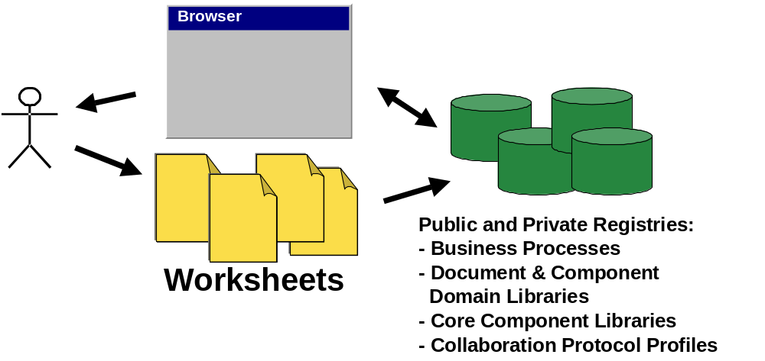Figure 5-1, Worksheets Architectural Context

The Analogy
The following analogy is useful in understanding the role of the Worksheets and other documentation and tools to the ebXML Business Process Collaboration Metamodel and the UN/CEFACT Modeling Methodology.
Item | United States Internal Revenue Service (IRS) Tax System
ebXML Business Process Collaboration Metamodel  UN/CEFACT Modeling Methodology. | Entire tax code
Worksheets and Templates | IRS Forms
Methodology Guidelines | IRS Instruction Booklets
Business Process Editor Tool Suite  Repository of Business Process Specifications, Core Components, etc. | Something like TurboTax and other software packages for preparing personal or business tax forms where these packages would have on-line access/search of all your tax and tax related records and the Tax code.

In order to actually specify a business process all we really need is the Worksheets and Templates. However, in order to ensure that we fill in the forms properly we will need to have a set of instructions that augment the templates and provide some of the rationale behind the templates.

Caveats and Assumptions

This document is non-normative; the documents identified above should be considered the authority on the definitions and specifications of the terminology used herein. This document is intended to be an application of those principals and technologies.

Worksheet Based Analysis Overview
As stated above, the purpose of this document is to provide worksheets that guide the user through the construction of a UMM compliant specification of their business processes. The following diagram shows mapping from the worksheets to the high level components of the UMM. Note, the document definition worksheet is currently not included in the set of worksheets.
Worksheets UMM Metamodel View
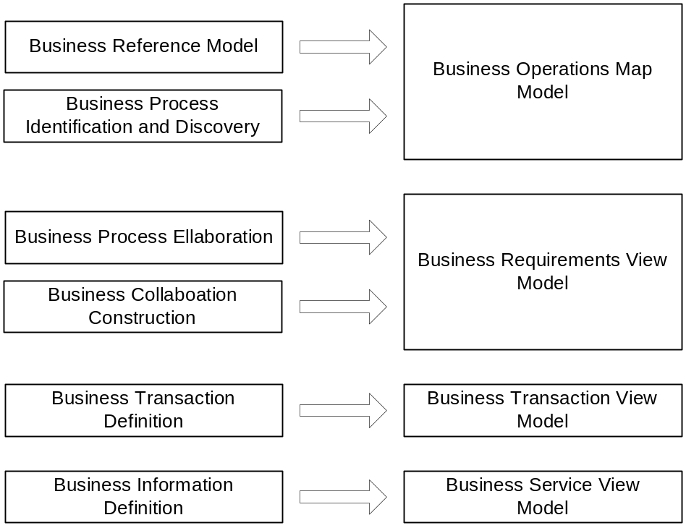
Figure 6-2 Overview of mapping from Worksheets to Metamodel
The expectation is that after the worksheets have been completed, there will be sufficient information to mechanically produce a Metamodel based specification of the modeled business process(es). The worksheets given above are:
Business Reference Model – Use this to define the “frame of reference” of the rest of the worksheets. This provides definitions of terms and, perhaps, canonical business processes (e.g. [SCOR])
Business Process Identification and Discovery – Use this to do an inventory of the business processes. This is really just a set of high-level use cases merely to identify the existence of processes and the stakeholders without going into detail.
Business Process Elaboration – These worksheets are used to flesh out the business processes. This identifies the actual actors as well as pre and post conditions for the business process.
Business Collaboration Definition – In these worksheets we define the economic events that take place to fulfill the business process. This is where one defines the system boundaries and the protocols that govern the flow of information.
Business Transaction Definition – These worksheets are more technically oriented than the others (which have a decidedly more “modeling” orientation). At this stage one defines the actual activities and authorized parties within the organization that initiate these transactions.
Business Information Definition – In these worksheets one defines the contents of the information field widths, data types, descriptions, requirement traceability and, perhaps, the additional context ([ebCNTXT]) necessary to construct the document from the Core Components subsystem.

Basic Guidelines for filling out Worksheets

Focus on public Business Processes
While these worksheets could be used to model any kind of business process, the focus of the ebXML effort is to make trading partner integration easier, cheaper, and robust. Therefore the expectation is that the primary focus will be on public faces of your business processes.

The REA Ontology
The UMM and ebXML groups are recommending the use of the Resource-Economic Event-Agent Ontology for the formalization of business collaborations.Please refer to [BPAO] and [REA] for further information on this topic and associated worksheets.

Use the worksheets in the order that makes the most sense for you
For the purposes of this document we proceed from the top-level step (Business Reference Model) down to the lowest-level step (Business Transaction). It is important to note, however, that these worksheets can be filled out in whatever order makes the most sense from the user’s perspective. For example, a person who is trying to retrofit an existing document based standard (e.g. EDIFACT) might want to start by filling in the Business Transaction Definition worksheets (perhaps only specifying trivial definitions for the higher level worksheets). A person looking to formalize the definitions for an entire industry may very well start from the Business Reference Model worksheet.

The worksheets can be used for projects of various scopes
Although the Metamodel has definite requirements on what objects need to be present to comprise a complete specification, it says little about the scope of what those specifications represent. For example, if you are only trying to model a specific interaction with one of your trading partners, you do not need to include a complete Business Reference Model for your entire industry, just include the parts that are directly relevant for the interaction you are modeling. Similarly, if you are just doing a small set of interactions for your company, you might choose to have the Business Area or Process Area just be your own company.

Think how will people use what you construct
As you fill in these worksheets please keep in mind how the generated UMM specification will be used by a user of the repository. The two principal uses envisioned are:
- To determine if a given collaboration is appropriate for reuse (or at least is a close enough match for subsequent gap analysis)
- To be used as an on-line implementation guide. A potential trading partner (or a 3rd party on their behalf) could examine the public processes/collaborations you provide and construct an integration plan.
This means trying to use industry wide terms (or at least Business Reference Model terminology) to increase the comprehensibility and specificity. .

Re-use is one of the primary goals of ebXML
As stated above, the hope is that users will develop models that are reusable by others. Towards that end, it is intended that the Worksheets be used in conjunction with a browser that lets the user search business process libraries for items that have already been defined. The items (e.g. business processes, business collaborations, document schemas, etc.) can be referenced (re-used as is) or copied to the worksheets and changed as needed. Over time, business process catalogs will become populated with a sufficiently large number of business processes. When this happens, the analysis processes will often become a matter of validating pre-defined business processes against requirements.

Note on optional fields in the worksheets
Some of the worksheets contain entries that are labeled as optional for ebXML. These are attributes that appear in the UMM but are not required as part of the ebXML Specification Schema. These are typically business objective/justification topics. While these are obviously very important aspects of any modeling endeavor, ebXML is oriented towards exposing an organization’s public processes to their trading partners. Advertising that organizations justifications for such interfaces could potentially publicize strategic information that said organization would prefer to keep private.

Number your worksheets
Each of the worksheets has an entry for a Form ID. This ID can be used to reference one form from another. In addition, if you use an outline numbering scheme, it will be easy for the reader to determine parent-child relationships between elements of the model (of course, if you do a bottom up approach this will be significantly harder to do up front!).
The recommended format is:
<Form Type>-<Number>-<Description>
Where <Form Type> is
BRM for Business Reference Model
BA for Business Area
PA for Business Process Area
BPS for Business Process Summary
BPUC for Business Process Use Case
EE for Economic Exchange
EA for Economic Agreement
BC for Business Collaboration
BCPT for Business Collaboration Protocol Table
BT for Business Transaction
BTTT for Business Transaction Transition Table
BIC for Business Information Context
CD for Content Description
CM for Content Mapping

<Number> is, perhaps, an outline entry number
<Description> is some descriptive name.
Please see the example in the Appendix for an illustration of this in practice.

Worksheets to Metamodel Mapping
The following diagram sketches out a more detailed mapping from the Worksheets Model to the Metamodel defined by the UMM. The leftmost column is the selection of the main elements that the Worksheets need to specify or edit. The rightmost column shows significant Metamodel elements. The middle column is the other elements that are part of the Worksheets. They are the same as the Metamodel elements of the same name.
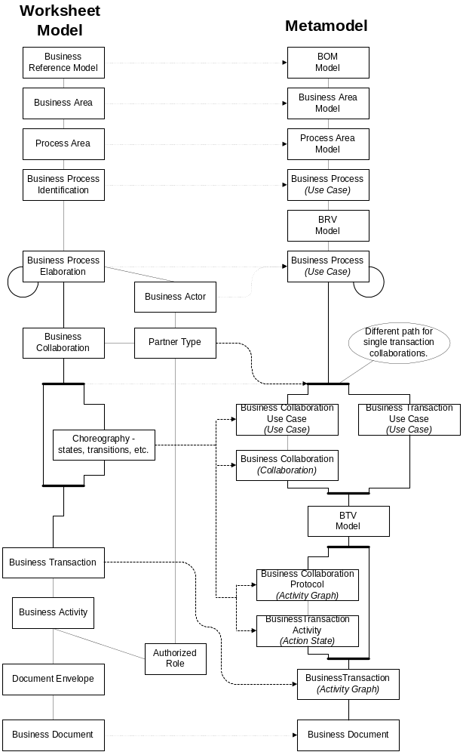

Business Process Identification and Discovery

Goals
The first set of worksheets helps the user begin formalize the domain they are trying to model processes in. The first stage in the methodology is to identify the “top level” entities and organizing concepts in the domain.
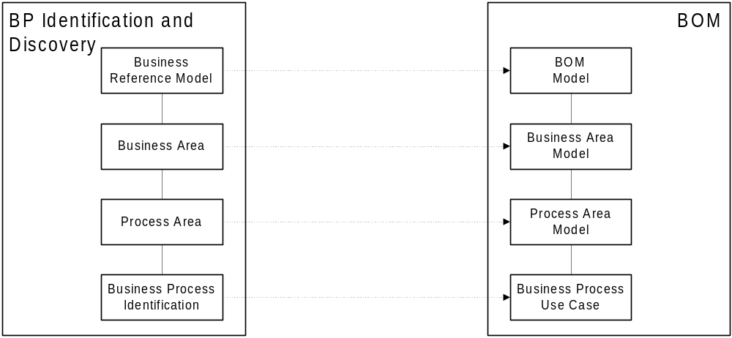
Figure 7-3 Business Process Identification and Discovery Worksheet to Metamodel Mapping
At this stage we define terminology and identify the participants as well as which business processes those players interact with. To quote the UMM, at this stage in the model the goal is to:
- To understand the structure and dynamics of the business domain,
- To ensure that all users, standards developers and software providers have a common understanding of the business domain,
- To understand the daily business in the business domain independent of any technical solution,
- To create categories to help partition the business domain that enables an iteration plan to complete the model,
- To structure the model in the form of a Business Operations Map (BOM),
- To capture the justification for the project,
- To identify the stakeholders concerned with the modeled domain, some who will be independent of the processes within the domain.
The modeling artifacts that correspond to the UMM are:
- Business Area [Package]
- Process Area [Package]
- Process(es) [Use Cases]

Guidelines

How does one decide how big to make the various groupings at this level?
Referring back to the primary guidelines, think about what you are trying to communicate. If you are more focused on identifying the public processes, then think about grouping them by partner type or, perhaps by the area of your business these partners interact with. If you are trying to formalize an entire business sector, determine the archetypes (patterns) that are prevalent in that sector and group them by business function area. These are just rules of thumb and this is still largely an “art”. Keep in mind your potential audience and think what would make the most useful organization for them.
The activity diagrams in this workflow will likely discover more refined business process use cases. The Business Operations Map (BOM) Metamodel allows a business process to be represented by more refined business processes. NOTE: At the point where the business process can not be broken down into more child business processes, the parent business process can be called a business collaboration use case as specified in the Requirements workflow.

What is the boundary of the business area?
According to the [UMM] the following guidelines are to be used in defining a business area:
- The business area can be defined by the stakeholders that have direct or immediate indirect influence on the business domain. A stakeholder is defined as someone or something that is materially affected by the outcome of the system but may or may not be an actor. Actors are stakeholders that are involved in the business process and are thus part of the business model.
- The business area can be defined by the information passing into or out of the business domain. Where possible, the domain boundaries should be chosen so that a business transaction is logically or organizationally initiated and concluded within them.
- The business area can be defined by key business entity classes. (i.e., things that are accessed, inspected, manipulated, processed, exchanged, and so on, in the business process)

Worksheets
The examples given in the following worksheets more or less come from the hypothetical business process described in section 8.4 of [bpPROC].

Business Reference Model
Often times it is useful to define a “frame of reference” for the business processes being identified. This frame of reference might define basic terms accepted by the given industry segment. For example the SCOR model defines a frame of reference for supply chain. VICS defines a frame of reference for trading partners in the retail industry. It also might be a more horizontal view such as the Porter Value Chain [PVC] (see table Appendix B).
Form: Describe Business Reference Model
Form ID | [Provide an ID for this form so other forms can reference it (§6.1.8)]
Business Reference Model Name | [Provide a name for the reference model. You can use an existing reference model such as the Supply Chain Council or the Porter’s Value Chain or create your own name.] DOTCOM DROP SHIP RETAIL MODEL
Industry Segment | [Provide the name of the industry segment that this business applies to. Search the business process library for a list of possible industry segments. If the industry segment does not exist, then provide an appropriate name/label for the industry segment.] Retail.
Domain Scope | [Provide a high level statement that encapsulates the scope of all the business areas.] Online catalog, distribution center, delivery, billing.
Business Areas | [List the business areas within the scope. A business area is a collection of process areas. A process area is a collection of business processes. You may wish to refer to the ebXML Catalog of Business Processes that provides a list of normative categories that may be used as business areas.] Order Management, AR.
Optional for ebXML
Business Justification | [Provide the business justification for the collection of business processes] Define more efficient on-line retailer/vendor interaction.

Business Area
As mentioned in the guidelines section, there are no hard and fast rules for how to divide up the model into different business areas. One suggestion is to group business processes according to the primary business function. You might consider using the Porter Value Chain [PVC] classification scheme (see Appendix B).
Form: Describe Business Area
Form ID | [Provide an ID for this form so other forms can reference it (§6.1.8)]
Business Area Name | [Provide a name for the business area. This should be listed in the Business Areas section of at least one Business Reference Model.]  Direct to Customer Retail
Description | [A brief summary of this functional area. ]
Scope | [Provide a high level statement that encapsulates the scope of all the business areas. The scope of the business area must be within the scope of the encompassing business reference model. Typically the scope of the business area will be more constrained or limited than the scope of the business reference model.] Online catalog, order placement, distribution center, delivery, billing.
Boundary of the Business Area | [Describe the boundary of the business area. This defines the entities that interact in this business area; actors, organizations, possibly systems] Customer, Retailer, DSVendor, Carrier, Credit Authority.
References | [Any external supporting documentation.] VICS, SCOR
Constraints | [Identify any constraints on the process areas (and, thus, business processes) within this business area.] 1. Completely automated system. 2. Web browser limitations. 3. Domestic orders only
Stakeholders | [Identify the practitioners that care about the definition of this business area. At this level, this is likely to be some participants in an industry group (perhaps a standards body or an enterprise). These are the people who will define the BRV.] Customer, Retailer, DSVendor, Carrier, Credit Authority.
Process Areas | [List the process areas within the scope. A process area is a collection of business processes. You may wish to refer to the ebXML Catalog of Business Processes that provides a list of normative process groups that may be used as process areas.] Customer Commitment, Order fulfillment, Billing, Inventory Management.
Optional for ebXML
Objective | [Describe the objective of this business area.] To deliver a product to a customer in a timely efficient manner.
Business Opportunity | [Describe the business opportunity addressed by this business area.]

Process Area
Typically a business reference model would define a canonical set of process areas (see the Porter or SCOR reference models for examples). A process area consists of a sequence of processes that are combined to form the “value chain” of the given business area.

Form: Describe Process Area
Form ID | [Provide an ID for this form so other forms can reference it (§6.1.8)]
Process Area Name | [Provide a name for the process area. This should be listed in the Process Areas section of at least one Business Area.] Order Fulfillment
Objective | [Describe the objective of this process area.] To deliver the goods ordered to the customer.
Scope | [Provide a high level statement that encapsulates the scope of all the business areas. The scope of the business area must be within the scope of the encompassing business reference model. Typically the scope of the process area will be more constrained or limited than the scope of the corresponding business area.] To fulfill customer’s order using the third party supplier for a drop ship delivery.
References | [External supporting documentation.]
Boundary of the Process Area | [Describe the boundary of the process area. The communicating services.] Retailer and third party vendor.  [Issue: How is this different than Scope?]
Constraints | [Identify any constraints on the business processes within this process area.] Inventory availability. On time delivery. System constrain.
Stakeholders | [Identify the practitioners involved in this process area. Question: is this a subset of those listed in the Business Area?.] Retailer, Third party vendor
Business Processes | [List the business processes within the scope of this process area. You may wish to refer to the ebXML Catalog of Business Processes that provides a normative list of business processes.] Manage Purchase Order.
Optional for ebXML
Business Opportunity | [Describe the business opportunity addressed by this process area.]

Identify Business Processes
For each business process in the process area fill in the following worksheet. A suggested rule of thumb for the appropriate granularity for a business process is that it is the smallest exchange of signals between stakeholders that has an identifiable economic value (cref. [REA]). Note that this is not always appropriate since “negotiation” could be a valid business process but it doesn’t really result in an economic consequence.
Be sure to validate the information in the process area against the encompassing business area. For example, validate that the scope of the process area is within the scope of its business area.
Form: Identify Business Process
Form ID | [Provide an ID for this form so other forms can reference it (§6.1.8)]
Business Process Name | [Provide a name for the business process. You may wish to refer to the ebXML Catalog of Business Processes [bpPROC] that provides a suggested set of commonly used business processes.] Manage Purchase Order
Process Area | [A process area is a group of business processes. Complete a Process Area form.] Order Fulfillment
Business Area | [A business area group together related process areas. Create a Business Area form.] Direct to Customer Retail

Business Process Elaboration

Goals
At this stage we begin to move from requirements analysis to design analysis. Consider the following diagram:
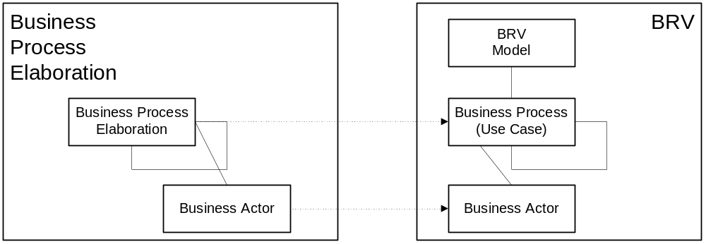
Figure 8-4 Mapping from business processes to the BRV
A business process is a use case that is used to gather requirements about business processes. Inputs to the business process must be specified in the preconditions and outputs from the business process must be specified in the post-conditions.

Worksheet
One of these is filled out for each business process. Business process can be nested. You should use whatever organization makes sense for your purposes (though you might want to think in terms of reuse when considering possible decompositions).
Form: Business Process Use Case
Form ID | [Provide an ID for this form so other forms can reference it (§6.1.8)]
Business Process Name | [Provide a name for the business process. This should be a name identified on the form “Identify Business Process” and on a “Describe Process Area” form. If you are starting with this form, you may wish to refer to the ebXML Catalog of Business Processes that provides a normative list of business processes.] Manage Purchase Order.
Identifier | [This is a unique identifier that follows the Business Process Identifier Naming Scheme. This can be provided when the business process description is submitted to a business process library. See Appendix A for a more detailed discussion.] bpid:ean.1234567890128:ManagePurchaseOrder$1.0
Actors | [List the actors involved in the use case.] Retailer, Vendor
Performance Goals | [A specification of the metrics relevant to the use case and a definition of their goals. Non-functional requirements may be a source of performance goals. For each performance goal, provide a name of the performance goal and a brief description of the performance goal.]
Preconditions | [Preconditions are constraints that must be satisfied starting the use case.] 1. Valid Sales Order 2. Valid Vendor Relation
Begins When | [Describe the initial event from the actor that starts a use case.] Sales Order Validation (expressed as events)
Definition | [A set of simple sentences that state the actions performed as part of the use case. Include references to use cases at extension points.] A valid Purchase Order placed by retailer with the vendor and a PO Ack is received from the vendor.
Ends When | [Describe the condition or event that causes normal completion of the use case.] PO Acknowledged returned to retailer.
Exceptions | [List all exception conditions that will cause the use case to terminate before its normal completion.] 1. PO Rejected (Failure state of a process) 2. Late PO acknowledged
Postconditions | [Post-conditions are states that must be satisfied ending the use case.] 1. Valid PO 2. Allocated Product
Traceability | [These are the requirements covered (as shown in Annex 4, Use Case Specification Template, in the UMM).] "PRD-FOO-6.5.4" (meaning Product Requirements Document for FOO project/solution, requirement 6.5.4).

Economic Elements

Goals
These worksheets develop the economic elements of business processes as elaborated in the REA ontology [REA]. The intent is to conform to the specific modeling elements of the Business Requirements View (BRV) of the UMM. Not all business processes include economic exchanges as defined by REA, so the use of these worksheets will occur in only a portion of business processes and business collaborations. The semantics of legal ownership and GAAP (generally accepted accounting principles) financial reporting depend upon correct modeling and understanding of the BRV elements in this section.

Guidelines
There are two worksheets in this section. These worksheets model the following economic entities: Economic Events, Economic Resources, Partner Types, Business Events, Agreements, Economic Contracts, and Commitments. Building an Economic Exchange model with these elements normally involves specification of two matching components of a marketplace exchange. For example:
A shipment (economic event) of goods (economic resource) between a supplier and a customer (partner types) occurs. This is normally followed by a payment (economic event) involving cash (economic resource) between the same two parties (partner types). This shipment for cash might have been preceded by quotes and pricing exchanges (business events). The shipment might also be governed by a purchase order (agreement or economic contract). This purchase order (economic contract) might specify the expected types of goods (economic resource types) and the expected dates of the shipments and payments (commitments).
The first worksheet specifies the items for an economic exchange, while the second specifies the economic primitives for the agreement that might govern that exchange. Not all economic exchanges are governed by agreements or contracts, so the second worksheet will be used less frequently. Where necessary, space has been provided for cross-references between economic exchanges and the agreements that govern them. It is also possible for agreements to recursively reference other agreements. Business Collaborations as defined in the next section of worksheets might correspond to an entire economic exchange, an economic event, or a business event. Collaborations may also correspond to agreements or economic contracts.

Worksheets
Form: Economic Exchange
Form ID | [Provide an ID for this form so other forms can reference it (§6.1.8)]
Economic Exchange Name | [Provide a name for the exchange (like “cash purchase” or “credit acquisition of services”)]
Identifier | [This is a unique identifier that follows the Business Process Identifier Naming Scheme.]
Initiator Resource Flow
Initiator Economic Event (s) | [Provide the business name for the economic event (shipment, service, payment, etc.)]
Initiator Economic Resource(s) | [Describe the goods or services (inventory, transportation, cash, etc.) to be exchanged.]
Initiator Supplying Partner Type | [Describe the party who supplies the economic resource.]
Initiator Receiving Partner Type | [Describe the party who receives the economic resource.]
Initiator Exception Events | [Describe the events that constitute the exceptions to the expected exchange and explain their consequences (incomplete shipment or disallowed payment, etc.).]
Terminator Resource Flow
Terminator Economic Event(s) | [Provide the business name for the economic event (shipment, service, payment, etc.)]
Terminator Economic Resource(s) | [Describe the goods or services (inventory, transportation, cash, etc.) to be exchanged.]
Terminator Supplying Partner Type | [Describe the party who supplies the economic resource
Terminator Receiving Partner Type | [Describe the party who receives the economic resource.]
Terminator Exception Events | [Describe the events that constitute the exceptions to the expected exchange and explain their consequences (incomplete shipment or disallowed payment, etc.).]
Overall Economic Exchange
Enabling Business Events | [Describe the business events that normally accompany this economic exchange and that enable its operation (For example: query availability, supply catalog information, and check credit might all precede a shipment of goods for cash).]
Normal Terms of Settlement | [Describe normal settlement arrangements (payment upon receipt, etc.).]
Recognition of Claim | [Describe whether or not an incomplete (unrequited) state of the exchange needs to be explicitly recognized with a claim (like an invoice).]
Need for Contract or Agreement | [Indicate whether or not this exchange is to be governed by an economic agreement or contract. If necessary, complete the next worksheet.]

Form: Economic Agreement
Form ID | [Provide an ID for this form so other forms can reference it (§6.1.8)]
Economic Agreement Name | [Provide a name or a specific identifier for the agreement that usually governs the economic exchange from the linked worksheet.]
Identifier | [This is a unique identifier that follows the Business Process Identifier Naming Scheme.]
Linked Worksheet for Economic Exchange | [Provide the Identifier for the governed economic exchange (as identified in prior worksheet).]
Governing Economic Agreement (Higher Order) | [Describe and provide Identifier for any longer term agreement that governs the operation of this specific (shorter-term) agreement.]
Governed Economic Agreement (Lower Order) | [Describe and provide Identifier for any shorter term agreement that are governed by the operation of this specific (longer-term) agreement.]
Economic Contract | [Describe whether or not this agreement meets the conditions for an enforceable legal contract.]
Parties to the Economic Agreement | [Identify the Partner Types resonsible for the establishment of the agreement.]
Establishing Event | [Identify the Business Event which establishes this agreement.]
Enabling Business Events | [Describe the set of Business Events that enabled the establishment of this agreement (from the negotiation pattern for example).]
Initiator Commitment(s) | Describe the nature of the initiating commitment for the governed exchange (for example: ship inventory according to a certain schedule).]
Initiator Resource Types | [Describe the Economic Resource Types for the initiating commitment and projected quantities if appropriate.]
Initiator Partner Type | [Identify the Partner Type responsible for the initiating commitment in the governed exchange.]
Terminator Commitment(s) | [Describe the nature of the terminating commitment for the governed exchange (for example: submit payment within 30 days of receipt).]
Terminator Resource Types | [Describe the Economic Resource Types for the initiating commitment and projected quantities if appropriate.]
Terminator Partner Type | [Identify the Partner Type responsible for the initiating commitment in the governed exchange.]

Business Collaboration

Goals
These worksheets develop the Business Requirements View (BRV) of a process model.

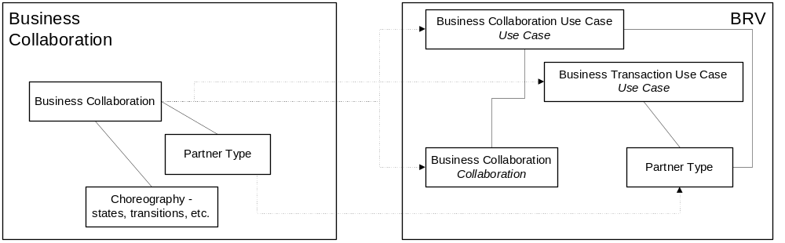
Figure 10-5 Mapping from Business Collaboration to BRV
The following items are specified:
- The business collaboration protocols that tie economic events together
- The system boundaries between which the protocols flow
- The input and output triggers of these collaborations
- The roles and constraints associated with the collaboration
The purpose of the Partner Collaboration Worksheets is:
“… to capture the detailed user requirements, specified by the stakeholders, for the business-to-business project. … This workflow develops the Business Requirements View (BRV) of a process model that specifies the use case scenarios, input and output triggers, constraints and system boundaries for business transactions (BTs), business collaboration protocols (BCPs) and their interrelationships.” ([UMM, 3.1])
The modeling artifacts to be identified are:
- Business Transactions [Use Case]
- Business Collaboration [Use Case]
- Business Collaboration Use Case [Use Case Realization, Activity Diagram]
- Economic Consequences of Business Collaborations

Worksheets
Detail the information in the table below for each business collaboration. Note that it may make sense to use UML diagrams to convey some of this information.
Form: Business Collaboration
Form ID | [Provide an ID for this form so other forms can reference it (§6.1.8)]
Identifier | [This is a unique identifier that follows the Business Process Identifier Naming Scheme. This can be provided when the business process description is submitted to a business process library. See Appendix A for a more detailed discussion.]
Description | [Provide a descriptive overview of the collaboration.]
Partner Types | [This is a list of entities that participate in the collaboration. These participants exchange the events that form the collaboration.]
Authorized Roles | [These are the roles that a partner must be authorized to play to issue specific transactions in the collaboration (by sending certain signals).]
Legal Steps/Requirements | [If any step in the collaboration has any legal standing, it should be captured here.]
Economic Consequences | [If any step in the collaboration has and economic consequence, it should be captured here.]
Initial/Terminal Events | [List the events that initiate this collaboration and how it terminates.]
Scope | [Specify the set of business actions this collaboration encapsulates.]
Boundary | [Specify the systems and users that communicate with each other over he course of this collaboration.]
Constraints | [Spell out any special constraints that are relevant to this collaboration (e.g. business scenario, pre-conditions.)]

Form: Business Collaboration Protocol Table
Form Id | [Provide an ID for this form so other forms can reference it (§6.1.8)]
Identifier | [Enter the Identifier from the associated Business Collaboration form.
From Business Activity (Transaction) | Initiating Partner Type | To Business Activity | Responding/ Receiving Partner Type | Transition Condition
[START for the first activity or the name of originating business activity.] | [Partner type name or NOT-APPLICABLE.] | [Name of destination business activity.] | [Partner type name or NOT-APPLICABLE.] | [A boolean expression defining or describing the condition for the transition or NONE.]
[Name of an activity.] | NOT-APPLICABLE | SUCCESS | NOT-APPLICABLE | [A boolean expression defining or describing the condition for the transition.]
[Name of an activity.] | NOT-APPLICABLE | FAILURE | NOT-APPLICABLE | [A boolean expression defining or describing the condition for the transition.]

Business Transactions and Authorized Roles

Goals
The goal of this worksheet is to identify the individual transactions that implement the workflow of a Business Collaboration. A transaction is made up of several activities and each activity has an authorized role that the signaler must have in order to initiate that activity.
The modeling artifacts generated as a result of this worksheet is the BusinessTransaction Activity Diagram. Fill out one worksheet for each transaction in the collaborations

Guidelines

Use Transaction Patterns
The UMM has defined several transaction patterns that should be used to define business transactions. By the use of these patterns one can be assured that the transaction is legally binding in accordance with current global and regional legal writings (see UMM for further details).
These patterns have intrinsic semantics (e.g. property-values such as non-repudiation and authorization) associated with them. If you choose to base the transaction on one of these patterns you do not have to repeat the property values here (although you may wish to do so that all information is specified in one place). However if you do not base the transaction on an UMM pattern, described the property values in the Business Transaction Property Values form. Note that if you do not follow a prescribed pattern, the business transaction may not comply with generally acceptable legally binding transaction semantics. If you wish to “override” the semantic property-values, use the Business Transaction Property Values form and keep in mind that when you change the property values, the pattern may no longer be applicable. In this case, you should not specify a pattern name. Do not provide values for Non-Repudiation Of Receipt and Recurrence for Responding Business Activity (this is specified by the UMM).

Detail Transaction Activities Only If Necessary
The transaction patterns defined in the UMM should be sufficient to cover most business cases. However, it may be necessary or desirable to describe the business transaction activity in terms of the allowable transitions between the activities. An UMM compliant activity diagram (UML) can be created or a Business Transaction Transition Table can be used to convey the same information. Refer to the examples in Appendix C, to see how Business Transaction activity diagrams are represented in Business Transaction Transition Table forms.

Worksheets
Form: Business Transaction
Form ID | [Provide an ID for this form so other forms can reference it (§6.1.8)]
Description | [Provide a descriptive overview of this transaction.]
Pattern | [If you have chosen to follow one of the canonical transaction patterns in the UMM (or elsewhere) denote it here. If not and you have special semantics (as mentioned above), describe them here.]
Business activities and associated authorized roles | [List each activity (along with its initiator) and the role required to perform that activity]
Constraints | [Any constraints should be listed here.]
Initiating/Requesting Partner Type | [Partner type from collaboration.] Customer
Initiating/Requesting Activity Role | [These are the roles that a partner must be authorized to play to issue specific transitions in the transaction (by sending certain signals).] Buying Customer
Initiating/Requesting Activity Document | [Document initiating the transaction. Might reference a standard document (e.g. an X12 document). ] Sales Order
Responding Partner Type | [See above.] On-line Retailer
Responding Activity Role | [See above.] Customer Service
Responding Activity Document | [See above.] Confirmation email

Complete the following property-values for requesting business activities and responding business activities if they differ from the default values defined in the UMM transaction patterns. You may wish to copy the values from the UMM as a convenience to the readers.
Form: Business Transaction Property Values
Form Id | [Provide an ID for this form so other forms can reference it (§6.1.8)]
 | Time to Acknowledge Receipt | Time to Acknowledge Acceptance | Time to Perform | Authorization Required | Non-repudiation of Origin and Content | Non-Repudiation of Receipt | Recurrence
Requesting Business Activity | [time] | [time] | [time] | [true or false] | [true or false] | [true or false] | [whole number]
Responding Business Activity | [time] | [time] | [time] | [true or false] | [true or false] | NOT-APPLICABLE | NOT-APPLICABLE

Provide a Business Transaction Transition Table if needed. See guidelines section “Detail Transaction Activities Only If Necessary.”
Form: Business Transaction Transition Table
Form Id | [Provide an ID for this form so other forms can reference it (§6.1.8)]
From Activity | From Role | Document | To Activity | To Role | Guard Condition
[Name of the “from” activity. The keyword START shall be used for the first activity.] | [A Requesting/Initiating Activity Role or NOT-APPLICABLE. NOT-APPLICABLE is to be used when the From Activity is START.] | [Document name or NONE.] | [Name of the destination activity or keyword END or keyword CONTROL-FAILED.] | [A Responding Activity Role or NOT-APPLICABLE.] | [A boolean expression defining or describing the condition for the transition or NONE.]
[Name of the last activity before the END state] | [Appropriate role name.] | NONE | END | NOT-APPLICABLE | [Expression of the guard condition.]
[Name of the last activity before the CONTROL-FAILED state.] | [Appropriate role name.] | NONE | CONTROL-FAILED | NOT-APPLICABLE | [Expression of the guard condition.]

Business Information Description

Goals
The goal of this set of worksheets is to identify the information requirements for the business documents specified in the business transactions.

Guidelines
The first step in specifying business documents in a business process and information model, is to attempt to reuse business information objects in a Business Library. If an existing business document cannot be found then, domain components from Domain Libraries and core components from the Core Library can be used. Until the Business Library is built up, or imported from a creditable source, core components are likely to be referred to frequently, to first add to the repertoire of business information objects in the Business Library, and second, to create business documents.
The steps for completing these worksheets are as follows:
- See what attributes are available in business information objects in the available Business Libraries that can be used in a business document.
- If business information objects with appropriate attributes as required for business documents are not available, new business information objects must be created.
- Look for re-usable information components in the business library and the Core Library as candidates for business information object attributes. Take context into account, as specified in the business process and information models. Extend existing business information objects, domain components, and core components as required.
- Add the new attributes to existing business information objects, or introduce new business information objects through a registration process that manages changes to the Business Library.
- Use the new attributes, now in the Business Library, as needed in creating the business documents.

Worksheets

Business Information Context
The Business Information Context form is provided as convenience for aggregating contextual values that effect the analysis of business information. It is intended that this information be obtained from other forms. For example, Industry Segment is specified in the Business Reference Model form. If there is no value for an entry, enter NOT-APPLICABLE or NONE which ever is appropriate.
Form: Business Information Context
Form Id: | [Provide an ID for this form so other forms can reference it (§6.1.8)]
Industry Segment
Business Process
Product
Physical Geography /Conditions /Region
Geo-Political Legislative/ Regulatory/ Cultural
Application Processing
Business Purpose /Domain
Partner Role
Service Level (profiles – not preferences.)
Contracts/Agreements

Document Content Description
Describe each element or group of elements in the document. Logically related elements can be placed in separate forms (For example, a document may have logically three parts, a header, body, and summary. The body may have further logical partitioning.). Possible values for Occurs include: 1 (one instance), 0..1 (zero on one instance), 0..* (zero or more instances), 1..* (one or more instances), or n..m (n to m instances where n is less than m). Information “looping” is specified through appropriate occurs values. Possible values for Data Type include primitive data types – such as integer, string, date-type – or a Form Id of another Content Description Form. Referencing another Content Description Form Id represents information hierarchy and nesting. If you happen to know the name of a reusable component from an domain library or the Catalog of Core Components, then you MAY reference it. The Semantic Description SHALL be stated in business terms and SHALL be unambiguous.
Form: Content Description
Form Id: | [Provide an ID for this form so other forms can reference it (§6.1.8)]
Element/Component Name |  | Occurs | Data Type | Field Width | Semantic Description | Notes
[Provide a name for the element/component. For example, “Order Summary” or “Issued Date.”]

Content Mapping
These forms SHOULD be completed. This information is very important as it shows that the documents have a basis in existing standards. Furthermore, the information will be used to create document transformations. Standards to map to include EDIFACT, X12, xCBL, RosettaNet, and other standards such as OBI. Use XPATH and XSLT notation for referencing XML elements and describing the mappings. If a new document schema is created to fulfil the content requirements specified in the Document Content Description forms, then a set of Content Mapping forms should be completed for that schema (the component names in the forms are simply requirements for information)
For each Content Description form, complete a Document Content Mapping form for each standard to be cross-referenced.
Form: Content Mapping
Form Id: |  | [Provide an ID for this form so other forms can reference it (§6.1.8)]
Content Description Form Id |  | [Provide the identifier of the associated Content Description form]
Standard |  | [Name of the standard. For example, UN/EDIFACT]
Version |  | [Standard version number. For example, D.01A]
Element/Component Name | Mapping/Transformation |  | Note
[Enter element/component name from corresponding Content Description form] | [Mapping or transformation. If the element/component is a complex structure, this entry should reference the appropriate Content Mapping form.] |  | [Any useful mapping notes.]

- Business Process Identifier Naming Scheme
It is recommended that the naming scheme, Business Identifier Naming Scheme, described in this appendix be applied to uniquely identify significant objects of an ebXML compliant business model. These objects directly relate to the layers of the UMM Metamodel. Specifically the Business Operations Map (BOM) with a Business Process Identifier naming Scheme (BPINS), the Business Requirements View with a Business Collaboration Identifier Scheme (BCINS) and the Business Transaction View with a Business Transaction Identifier Scheme (BTINS).
A BPINS naming scheme format is defined by :
bpid:<agency>:<agency-id>:<business-process-name>$<major-version-number>.<minor-version-number>
A BCINS naming scheme format is defined by :
bcid:<agency>:<agency-id>:<business-collaboration-name>$<major-version-number>.<minor-version-number>
A BTINS naming scheme format is defined by :
btid:<agency>:<agency-id>:<business-transaction-name>$<major-version-number>.<minor-version-number>
Where
- bpid is the fixed string “bpid” indicating the entire identifier is a business process identifier.
- bcid is the fixed string “bcid” indicating that the entire identifier is a business collaboration identifier.
- btid is the fixed string “btid” indicating that the entire identifier is a business transaction identifier.
- agency identifier or name of the agency that owns the agency-ids and must be a globally unique identifier. For example, DUNS and EAN.
- agency-id identifer of the organization that owns the business process and must be a globally unique identifier. No other entity SHALL use the agency identification of another entity.
- Major and minor version numbers are each integers and need to respect any specific Registry Authority conventions defined.
The business-process-name, business-collaboration-name, business-transaction-name should be descriptive names. It is recommended that the descriptive name be in camel-case. The names must not contain spaces, periods, colons, or dollar signs. The organization or agency-id that owns the business transaction SHALL be responsible for guaranteeing that the identifier is unique..
Valid examples of business processes using the identifier naming scheme include :
btid:ean.1234567890128:DistributeOrderStatus$1.0
bpid:icann:my.com:NewBusinessProcess$2.0
With respect to the ebXML Registry Information Model specification the definition is as follows:
BPINS Registry Information Model
bpid ExtrinsicObject.objectType
bcid ExtrinsicObject.objectType
btid ExtrinsicObject.objectType
agency Organization.name
agencyid Organization.uuid
business-process-name ExtrinsicObject.name
business-collaboration-name ExtrinsicObject.name
business-transaction-name ExtrinsicObject.name
major-version-number ExtrinsicObject.majorVersion
minor-version-number ExtrinsicObject.minorVersion

An ExtrinsicObject is a special type of ManagedObject (one that goes through a defined life cycle); the extrinsic object is not required for the core operation of a registry. An Organization is defined as an IntrinsicObject; it is core to the function of a registry.
- The Porter Value Chain
The following table shows the categories of the Porter Value Chain [PVC] and how they map to Economic Elements concepts. This is included as an aid to help users formalize their classification of the elements of a business process specification.
Normative Category | Normative Sub-Category | Resource inflows & outflow | Major types of events | Economic Agents & Roles
Procurement | Bid Submission  Contract Negotiation  Purchase Order Preparation  Receiving | Money  Raw materials  Facilities  Services  Technology | Payments  Purchase  Purchase Orders  Price Quotes  Contract Negotiation | Buyer  Seller  Vendor  Cashier
Human Resources | Hiring  Training  Payroll Management  Personnel Deployment | Money  Purchased training materials  Purchased benefit packages | Cash Payments  Acquisition of labor  Training | Employee  Student  Beneficiary
Transportation | Loading  Shipping  Packaging | Raw Materials  Delivered Raw Materials  Manufactured Goods  Delivered Manufact. Goods | Shipment  Warehousing Tasks  Material Handling  Trucking | Buyer  Vendor  Logistics Worker  Trucker
Manufacturing | Product Development  Product Design  Assembly  Quality control | Facilities & Technology  Labor  Raw Materials  Finished Goods | Manufacturing Operation  Raw Material Issue  Manufacturing Job | Factory Worker  Supervisor  QC Inspector
Marketing & Sales | Advertising Use & Campaigning  Marketing Management  Sales Calling  Customer Credit Management | Labor  Advertising Service  Delivered Goods  Product Services  Cash | Cash Payment  Customer Invoice  Sale Order  Price Quotes  Contract Negotiation | Customer  Salesperson  Cashier
Customer Service | After Sales Service  Warranty Construction | Labor  Purchased Services  Product Warranties and Services | Service Call  Product Repair  Service Contract | Customer Service Agent  Customer
Financing | Loan Management  Stock Subscriptions and Sales  Dividend Policy | Cash  Bonds  Stocks  Derivative Instruments | Interest Payments  Stock Subscriptions  Dividend Declarations  Cash Receipts | Stockholders  BondHolders  Investment Brokers  Financial Managers
Administration | Accounting  Financial Reporting  Executive Management | Employee Labor | Employee Service  Management Projects | Managers  Clerks

- Drop Ship Scenario Example
This appendix provides an example of the worksheet-based analysis for a business reference model, “Direct to Customer Drop Ship Retail.” In many cases, UMM UML diagrams are provided. As with the rest of this document, it is work in progress. It is our hope that you find this information helpful in understanding how you can make these worksheets work for you.
Form Number | Form Type
1.# | Top level of Business Reference Model : defines the “frame of reference” of all worksheets.
2.# | Business Process Area : Form that defines the scope of the business area
3.# | Business Process Identification and Discovery : Forms that inventory all business processes.
4.# | Business Process Summary Name form
5.# | Business Process Elaboration : Forms used to describe the business processes and identify actors as well as pre and post conditions for the business processes. (use cases)
6.# | Business Collaboration Definition : define the economic events that take place to fulfill the business process, including system boundaries and the protocols that govern the flow of information.
7.# | Collaboration Transitions
8.# | Business Transaction Definition : Forms that defines the actual activities and authorized parties within the organization that initiate these transactions.
9.# | Content/document definition
10.# | Business information context
11.# | Content mapping

Model Contents

C.1 Business Process Identification and Discovery: BRM-1.0-Direct-To-Customer-Drop-Ship-Retail-Model 47
C.1.1 Business Areas 49
C.1.2 Direct To Customer Retail Process Areas 51
C.1.3 Financial Process Areas 56
C.1.4 Customer-Order-Management Business Process Summaries 56
C.1.5 Customer Order Fulfillment Business Process Summaries 58
C.1.6 Vendor Inventory Management Processes Summaries 58
C.1.7 Product Catalog Exchange Business Processes Summaries 59
C.1.8 Payment Business Process Summaries 59
C.2 Business Process Elaboration 60
C.2.1 BPUC-5.1-Firm-Sales-Order 60
C.2.2 BPUC-5.2-Customer-Credit-Inquiry 62
C.2.3 BPUC-5.3-Customer-Credit-Payment 64
C.2.4 BPUC-5.4-Purchase-Order-Management 65
C.2.5 BPUC-5.5-Ship-Goods 66
C.2.6 BPUC-5.6-Inventory-Management 67
C.2.7 BPUC-5.7-Sales-Product-Notification 68
C.2.8 BPUC-5.8-Present-Invoice 68
C.3 Business Collaboration and Economic Events 70
C.3.1 BC-6.1-Create-Customer-Order 70
C.3.2 BC-6.2-Check-Customer-Credit 72
C.3.3 BC-6.3-Process-Credit- Payment 74
C.3.4 BC-6.4-Create-Vendor-Purchase-Order 76
C.3.5 BC-6.5-Shipment-Instruction 78
C.3.6 BC-6.6-Confirm-Shipment 80
C.3.7 BC-6.7-Vendor-Inventory-Reporting 82
C.3.8 BC-6.8-Request-Inventory-Report 84
C.3.9 BC-6.9-Sales-Product-Offering 85
C.3.10 BC-6.10-Invoice-Presentment 87
C.4 Business Transactions and Authorized Roles 89
C.4.1 BT-8.1-Firm-Customer-Sales-Order 89
C.4.2 BT-8.2-Check Customer Credit 90
C.4.3 BT-8.3-Charge-Customer-Credit 91
C.4.4 BT-8.4-Create-Vendor-Purchase-Order 93
C.4.5 BT-8.5-Vendor-Inventory-Report 95
C.4.6 BT-8.6-Request-Inventory-Report 97
C.4.7 BT-8.7-Shipment-Notification 99
C.4.8 BT-8.8-Confirm-Shipment 101
C.4.9 BT-8.9-Product-Offering 103
C.4.10 BT-8.10-Present-Invoice 105
C.5 Business Information Description 107
C.5.1 Purchase Order 107
C.5.2 Content Mapping 110

Table Of Figures
Figure 12-1, Direct To Customer Retail Transaction and Physical Goods Flow Overview 47
Figure 12-2, <<BusinessOperationsMap>>Direct To Customer Drop Ship Retail 48
Figure 12-3, <<BusinessArea>>Direct to Customer Retail 50
Figure 12-4, <<BusinessArea>> Finance 51
Figure 12-5, <<ProcessArea>>Customer Order Management 52
Figure 12-6, <<ProcessArea>>Customer Order Fulfillment 53
Figure 12-7, <<ProcessArea>>Vendor Inventory Management 54
Figure 12-8, <<ProcessArea>>Product Catalog Exchange 55
Figure 12-9, <<ProcessArea>> Payment 56
Figure 12-13, <<BusinessCollaborationProtocol>> CreateCustomerOrder 71
Figure 12-14, <<BusinessCollaborationProtocol>> CheckCustomerCredit 73
Figure 12-15, <<BusinessCollaborationProtocol>> ProcessCreditPayment 75
Figure 12-16 , <<BusinessCollaborationProtocol>> CreateVendorPurchaseOrder 77
Figure 12-17, <<BusinessCollaborationProtocol>> ShipmentInstruction 79
Figure 12-18, <<BusinessCollaborationProtocol>> ConfirmShipment 81
Figure 12-19, <<BusinessCollaborationProtocol>> VendorInventoryReporting 83
Figure 12-20, <<BusinessCollaborationProtocol>> RequestInventoryReport 84
Figure 12-21, <<BusinessCollaborationProtocol>> SalesProductOffering 86
Figure 12-22, <<BusinessCollaborationProtocol>> InvoicePresentment 87
Figure 12-23, <<BusinessTransaction>> FirmCustomerSalesOrder 90
Figure 12-24, <<BusinessTransaction>> PurchaseOrderRequest 94
Figure 12-25, <<BusinessTransaction>> VendorInventoryReport 96
Figure 12-26, <<BusinessTransaction>> RequestInventoryReport 98
Figure 12-27, <<BusinessTransaction>> ShipmentInstruction 100
Figure 12-28, <<BusinessTransaction>> ConfirmShipment 102
Figure 12-29, <<BusinessTransaction>> ProductOffering 104
Figure 12-30, <<BusinessTransaction>> PresentInvoice 106

  - Business Process Identification and Discovery: BRM-1.0-Direct-To-Customer-Drop-Ship-Retail-Model

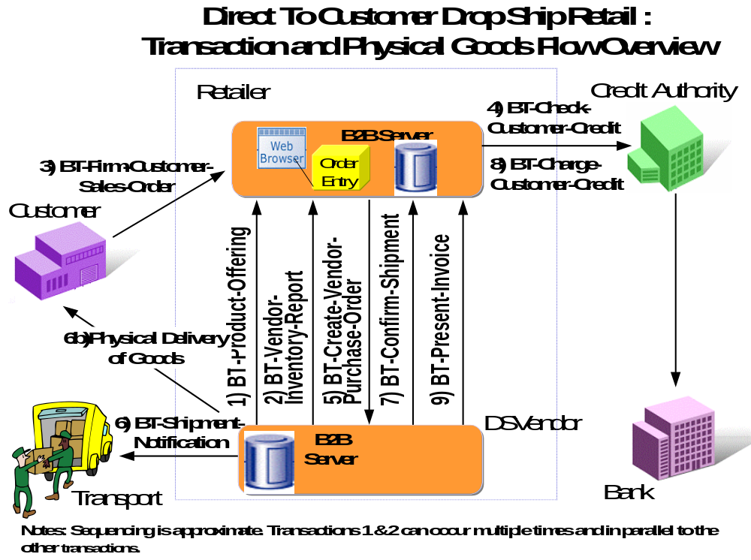
Figure 12-6, Direct To Customer Retail Transaction and Physical Goods Flow Overview

Form: Business Reference Model
Form Id | BRM-1.0-Direct-To-Customer-Drop-Ship-Retail-Model
Business Reference Model Name | DIRECT TO CUSTOMER DROP SHIP RETAIL MODEL
Industry Segment | Retail
Domain Scope | Internet retail, catalog, distribution center, delivery, billing.
Business Areas | - Direct To Customer Retail  - Finance
Optional for ebXML
Business Justification | Define more efficient on-line retailer/vendor interaction. Reduce inventory carrying costs.

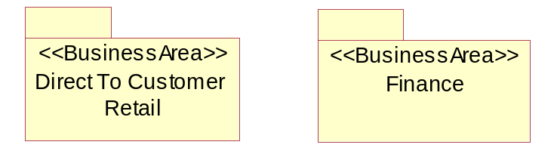
Figure 12-7, <<BusinessOperationsMap>>Direct To Customer Drop Ship Retail
    - Business Areas
      - BA-2.0-Direct-to-Customer-Retail
Form: Business Area
Form Id | BA-2.0-Direct-to-Customer-Retail
Business Area Name | Direct to Customer Retail
Description | This is a demonstrative business process model, to illustrate ebXML business process modeling, and based on actual business practice conventions today.  See ‘Objective’ section below in this form.
Scope | Internet based retail, mail order catalog, direct to customer product fulfillment logistics, single piece product delivery from a distribution center to an end customer.
Boundary of the Business Area | - Customer  - Retailer  - Direct Supply Retail Vendor (DSVendor)  - Transport Carrier  - Credit Authority
References | - EAN International  - Global Commerce Initiative  - VICS  - SCOR  - “my company typical Vendor Compliance Manual”
Constraints | - Internet based retail customer service system  - Web browser limitations.  - Domestic customer orders only
Stakeholders | - Customer  - Retailer  - Direct Supply Retail Vendor (DSVendor)  - Transport Carrier  - Credit Authority
Process Areas | - Customer Order Management  - Customer Order Fulfillment  - Vendor Inventory Management  - Product Catalog Exchange
Optional for ebXML
Objective | To deliver a commercial product directly to a customer, in a timely and efficient manner directly from a product supply source, with an online Internet retailer taking the customer order and providing direct customer service management.
Business Opportunity | Reduce retailer inventory carrying costs. Shorten the supply chain from a domestic vendor to a domestic customer; thus save trees, energy and lives.
Notes:
- The Business Area diagram (below) shows all the process areas in this business area.
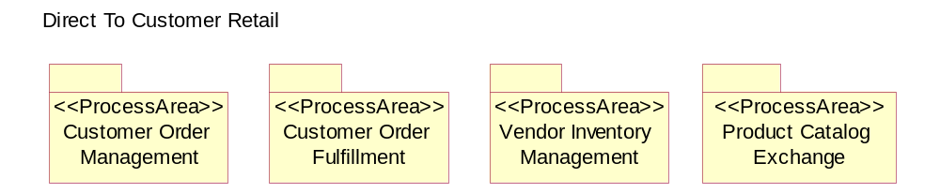
Figure 12-8, <<BusinessArea>>Direct to Customer Retail
      - BA-2.1-Finacial
Form: Business Area
Form Id | BA-2.1-Finacial
Business Area Name | Finacial
Description
Scope
Boundary of the Business Area | - Retailer  - Direct Supply Retail Vendor (DSVendor)
References
Constraints
Stakeholders | - Retailer  - Direct Supply Retail Vendor (DSVendor)
Process Areas | - Payment
Optional for ebXML
Objective
Business Opportunity

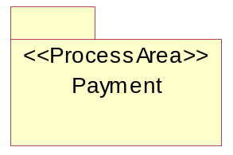
Figure 12-9, <<BusinessArea>> Finance

    - Direct To Customer Retail Process Areas
      - PA-3.1-Customer-Order-Management
Form: Business Process Area
Form Id | PA-3.1-Customer-Order-Management
Process Area Name | Customer Order Management
Objective | - Take a sales order from an Internet based customer  - Validate a customer’s ability to pay for product upon delivery  - Take payment from a customer’s credit card after a product has been delivered directly to a customer
Scope | - Fulfill customer orders using a 3rd party supplier for drop ship (customer direct) delivery.
References | - “my company Vendor Operations Compliance Manual”
Boundary of the Process Area
Constraints | - Customer promise of product availability most likely true at a vendor location when a customer order is accepted by the retailer.  - Customer must have sufficient credit to eventually pay for the product after the product has been shipped.
Stakeholders | - Customer  - Retailer  - Credit Authority
Business Processes | - Firm Sales Order  - Customer Credit Inquiry  - Customer Credit Payment
Optional for ebXML
Business Opportunity

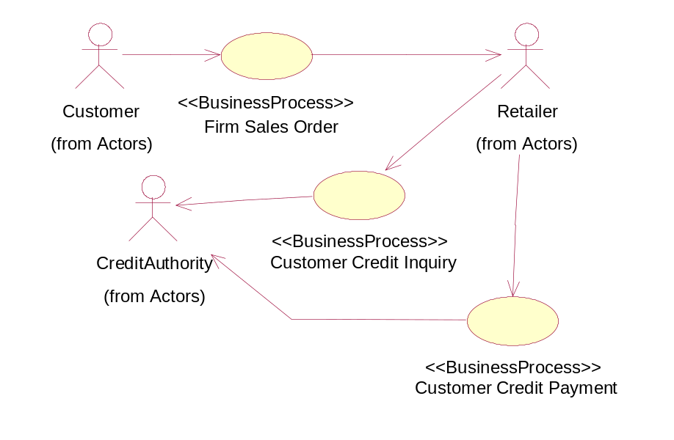
Figure 12-10, <<ProcessArea>>Customer Order Management
      - PA-3.2-Customer-Order-Fulfillment
Form: Business Process Area
Form Id | PA-3.2-Customer-Order-Fulfillment
Process Area Name | Customer Order Fulfillment
Objective | Allow a retailer to instruct a direct supply vendor to deliver (within specific delivery times) specific product to a specific customer.
Scope
References | - “my company Vendor Compliance Operating Manual”
Boundary of the Process Area | Activities directly pertaining to the registration of firm customer sales orders, and credit payment of delivered customer sales orders.
Constraints | - On hand product allocation to a customer order by a vendor immediately after processing a retailer’s purchase order.  - On time product delivery from vendor to customer.  - Immediate notification by a vendor to a retailer of a direct to customer product delivery; with customer service details.
Stakeholders | - Retailer  - DSVendor  - Transport Carrier  - Customer
Business Processes | - Purchase Order Management  - Ship Goods
Optional for ebXML
Business Opportunity

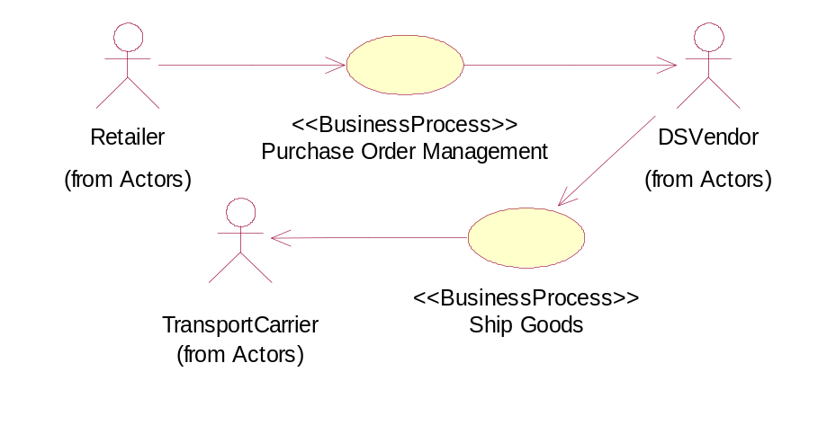
Figure 12-11, <<ProcessArea>>Customer Order Fulfillment
      - PA-3.3-Vendor-Inventory-Management
Form: Business Process Area
Form Id | PA-3.3-Vendor-Inventory-Management
Process Area Name | Vendor Inventory Management
Objective | To allow a direct supply vendor to report “available on-hand” inventory to a retailer.
Scope
References | - “my company Vendor Compliance Operating Manual”
Boundary of the Process Area
Constraints | - Inventory, by product SKU identification, is “available on-hand” within the direct supply vendor’s inventory management system.
Stakeholders | - Retailer  - DSVendor
Business Processes | - Inventory Management
Optional for ebXML
Business Opportunity

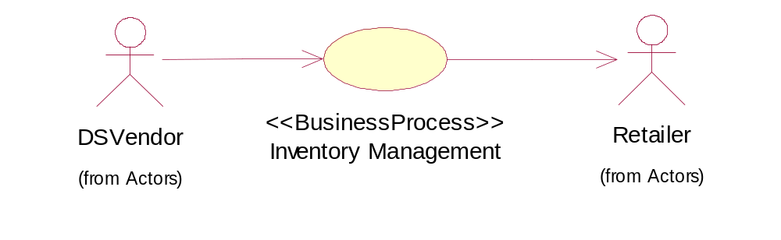
Figure 12-12, <<ProcessArea>>Vendor Inventory Management
      - PA-3.4-Product-Catalog-Exchange
Form: Business Process Area
Form Id | PA-3.4-Product-Catalog-Exchange
Process Area Name | Product Catalog Exchange
Objective | To maintain an accurate catalog (list) of a vendor’s products, in a retailer’s business operating system; especially as vendor’s products are introduced to the market or existing products require updated product specifications between the vendor and the retailer.
Scope
References | - “my company Vendor Compliance Operating Manual”
Boundary of the Process Area
Constraints | - Existence of a valid business operating relationship between a specific vendor and a retailer, such that products offered by a vendor can be in turn offered to an end customer by the retailer.
Stakeholders | - Retailer  - DSVendor
Business Processes | - Sales Product Notification
Optional for ebXML
Business Opportunity

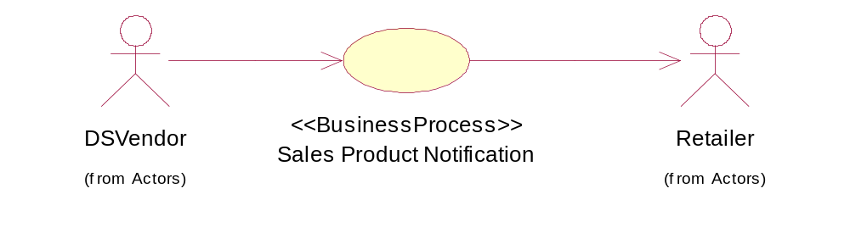
Figure 12-13, <<ProcessArea>>Product Catalog Exchange

    - Financial Process Areas
      - PA-3.5-Payment
Form: Business Process Area
Form Id | PA-3.5-Payment
Process Area Name | Payment
Objective | For the vendor to invoice the retailer for goods shipped and services provided.
Scope | The scoped is defined by the following business processes:  - Present Invoice
References | - “my company Vendor Compliance Operating Manual”
Boundary of the Process Area
Constraints | - Valid business relationship
Stakeholders | - Retailer  - DSVendor
Business Processes | - Present Invoice
Optional for ebXML
Business Opportunity

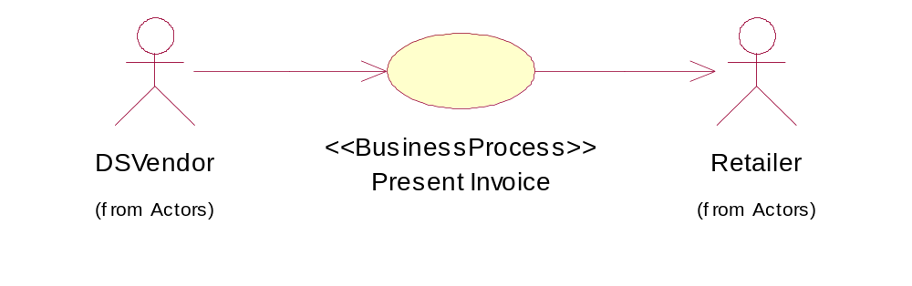
Figure 12-14, <<ProcessArea>> Payment
    - Customer-Order-Management Business Process Summaries
      - BPS-4.1-Firm-Sales-Order
Form: Business Process Summary
Form Id | BPS-4.1-Firm-Sales-Order
Business Process Name | Firm Sales Order
Identifier | bpid:ean.1234567890128:FirmSalesOrder$1.0
Process Area | Customer Order Management
Business Area | Direct to Customer Retail
      - BPS-4.2-Customer-Credit-Inquiry
Form: Business Process Summary
Form Id | BPS-4.2-Customer-Credit-Inquiry
Business Process Name | Customer Credit Inquiry
Identifier | bpid:ean.1234567890128:CustomerCreditInquiry$1.0
Process Area | Customer Order Management
Business Area | Direct to Customer Retail
      - BPS-4.3-Customer-Credit-Payment
Form: Business Process Summary
Form Id | BPS-4.3-Customer-Credit-Payment
Business Process Name | Customer Credit Payment
Identifier | bpid:ean.1234567890128:CustomerCreditPayment$1.0
Process Area | Customer Order Management
Business Area | Direct to Customer Retail

    - Customer Order Fulfillment Business Process Summaries
      - BPS-4.4-Purchase-Order-Management
Form: Business Process Summary
Form Id | BPS-4.4-Purchase-Order-Management
Business Process Name | Purchase Order Management
Identifier | bpid:ean.1234567890128:PurchaseOrderManagement$1.0
Process Area | Customer Order Fulfillment
Business Area | Direct to Customer Retail

      - BPS-4.5-Ship-Goods
Form: Business Process Summary
Form Id | BPS-4.5-Ship-Goods
Business Process Name | Ship Goods
Identifier | bpid:ean.1234567890128:ShipGoods$1.0
Process Area | Customer Order Fulfillment
Business Area | Direct to Customer Retail

    - Vendor Inventory Management Processes Summaries
      - BPS-4.6-Inventory-Management
Form: Business Process Summary
Form Id | BPS-4.6-Inventory-Management
Business Process Name | Inventory Management
Identifier | bpid:ean.1234567890128:InventoryManagement$1.0
Process Area | Vendor Inventory Management
Business Area | Direct to Customer Retail

    - Product Catalog Exchange Business Processes Summaries
      - BPS-4.7-Sales-Product-Notification
Form: Business Process Summary
Form Id | BPS-4.7-Sales-Product-Notification
Business Process Name | Sales Product Notification
Identifier | bpid:ean.1234567890128:SalesProductNotification$1.0
Process Area | Product Catalog Exchange
Business Area | Direct to Customer Retail

    - Payment Business Process Summaries
      - BPS-4.8-Invoice-Presentment
Form: Business Process Summary
Form Id | BPS-4.8- Present-Invoice
Business Process Name | Present Invoice
Identifier | bpid:ean.1234567890128:PresentInvoice$1.0
Process Area | Payment
Business Area | Finance

  - Business Process Elaboration
    - BPUC-5.1-Firm-Sales-Order
Form: Business Process Use Case
Form Id | BPUC-5.1-Firm-Sales-Order
Business Process Name | Firm Sales Order
Identifier | bpid:ean.1234567890128:FirmSalesOrder$1.0
Actors | - Customer  - Retailer
Performance Goals | - Accept a firm customer sales order for a product, and promise the customer a delivery time at total sales amount including all taxes within seconds after the customer has made a product choice and given relevant personal details; ie. while customer is online.
Preconditions | - Valid customer details (name, address, credit card)  - Valid product details (product SKU details)
Begins When | - Customer completes all personal identity data for Retailer.  - Customer successfully selects valid product to be purchased and specifies valid product quantity.  - Customer accepts terms of sale.
Definition | - Retailer needs to validate customer’s credit limit with a Credit Authority, and if enough credit is available to cover the product to be purchased, the Retailer will accept the Customers firm sales order.
Ends When | - Valid customer sales order is created in Retailer’s business operating system.
Exceptions | - Customer fails internal credit check; ie. fraud.  - Customer delivery needs violate Retailers standard terms of sale.
Postconditions | - Valid customer sales order.  - Customer is notified of positive sale, and can expect delivery within promised delivery time.
Traceability | Not Applicable

    - BPUC-5.2-Customer-Credit-Inquiry
Form: Business Process Use Case
Form Id | BPUC-5.2-Customer-Credit-Inquiry
Business Process Name | Customer Credit Inquiry
Identifier | bpid:ean.1234567890128:CustomerCreditInquiry$1.0
Actors | - Retailer  - Credit Authority
Performance Goals | - Retailer expects the Credit Authority to perform a credit card check for a specified sales amount and in seconds.
Preconditions | - Customer credit card details known.  - Total sales price, including taxes, known.
Begins When | - Retailer can present both all customer credit card details and a requested total credit amount to be checked against this customer.
Definition | - Retailer requests Credit Authority to authorize the total sales amount against the customer’s credit amount.  - The Credit Authority responds to the Retailer with either a positive or negative credit report on the customer.
Ends When | - Credit Authority returns either a positive or negative Customer report.
Exceptions | - Credit Authority fails to respond to Retailer within an acceptable period.
Postconditions | - Customer has a reserved credit cash equal to the total purchase amount authorized to the Retailer for a 24 hour period.
Traceability | Not Applicable

    - BPUC-5.3-Customer-Credit-Payment
Form: Business Process Use Case
Form Id | BPUC-5.3-Customer-Credit-Payment
Business Process Name | Customer Credit Payment
Identifier | bpid:ean.1234567890128:CustomerCreditPayment$1.0
Actors | - Retailer  - Credit Authority
Performance Goals | - Retailer expects Credit Authority to positively charge the Customer’s credit for the total sales amount immediately upon request.
Preconditions | - Confirmed shipment, by Vendor, of purchased product direct to Customer.
Begins When | - Vendor confirms to Retailer that the specified product prescribed on the current updated version of a DSVendor’s purchase order has been actually shipped to the specified customer.
Definition | - Credit Authority makes a credit charge against the Customer’s account, on behalf of the Retailer.  - Credit Authority reports, to Retailer, the status of the credit charge.
Ends When | - Credit Authority reports back to the Retailer that the customer’s credit has been charged for the total sales amount; and thus credited to the Retailer’s account.
Exceptions | - Credit Authority reports to Retailer that the customer’s credit account cannot be charged with total sales price.
Postconditions | - Credit Authority transfers total sales amount from the Customer’s account to the Retailer’s account.
Traceability | Not Applicable
    - BPUC-5.4-Purchase-Order-Management
Form: Business Process Use Case
Form Id | BPUC-5.4-Purchase-Order-Management
Business Process Name | Purchase Order Management
Identifier | bpid:ean.1234567890128:PurchaseOrderManagement$1.0
Actors | - Retailer  - Vendor
Performance Goals | - DSVendor returns a PO Acknowledgment to the Retailer within 4 hours of receipt of the Purchase Order.
Preconditions | - Valid Customer sales order with Retailer.  - Valid Retailer–DSVendor relation; ie. terms and conditions.
Begins When | - Retailer has created a valid Purchase Order Request.
Definition | - Upon receiving a Purchase Order Request, the DSVendor does a product allocation to the PO against available inventory and returns a positive PO Acknowledgment to the Retailer.
Ends When | - Valid positive PO Acknowledgment returned from the DSVendor to the Retailer.
Exceptions | - DSVendor does not return any PO Acknowledgment  - DSVendor returns a negative Purchase Order Acknowledgement
Postconditions | - DSVendor has allocated correct product to fill Purchase Order  - DSVendor has created all correct instructions for its warehouse management system to pick, pack and ship.
Traceability | Not Applicable

    - BPUC-5.5-Ship-Goods
Form: Business Process Use Case
Form Id | BPUC-5.5-Ship-Goods
Business Process Name | Ship Goods
Identifier | bpid:ean.1234567890128:ShipGoods$1.0
Actors | - DSVendor  - Transport Carrier
Performance Goals | - Transport Carrier informs DSVendor within seconds of PO pickup, and DSVendor registers PO transport tracking number within its business operating system within seconds.
Preconditions | - PO has been picked, packed and is ready to be shipped.
Begins When | - DSVendor informs Transport Carrier of a PO needing to be delivered to a specific Customer address.
Definition | - DSVendor manifests PO with Transport Carrier  - Transport Carrier registers transport, checks “ship to” details and assigns a tracking number for the shipment.
Ends When | - Transport Carrier confirms PO pickup to DSVendor and begin of ordered goods delivery to Customer.
Exceptions | - Transport Carrier detects that “Ship To” address is invalid.  - Transport Carrier fails to confirm PO pickup.
Postconditions | - Carrier assigns Transport tracking number to Purchase Order and informs DSVendor of tracking number.
Traceability | Not Applicable

    - BPUC-5.6-Inventory-Management
Form: Business Process Use Case
Form Id | BPUC-5.6-Inventory-Management
Business Process Name | Inventory Management
Identifier | bpid:ean.1234567890128:InventoryManagement$1.0
Actors | - Retailer  - DSVendor
Performance Goals | - Once a day, the DSVendor reports their “available on-hand” inventory to the Retailer.
Preconditions | - Valid business agreement.
Begins When | - Repeating event, occurs unsolicited from DSVendor to Retailer.
Definition | - DSVendor reconciles “available on-hand” inventory and reports only product availability for those products which are agreed upon between Retailer and DSVendor.
Ends When | - Retailer has received a valid “available on-hand” inventory report from DSVendor.
Exceptions | - No “available on-hand” inventory report received.  - Reported product quantiry on hand with DSVendor is less than any prior agreed Safety Stock level with Retailer.
Postconditions | - Retailers business operating system has recorded new “available on-hand” inventory by product.
Traceability | Not Applicable
    - BPUC-5.7-Sales-Product-Notification
Form: Business Process Use Case
Form Id | BPUC-5.7-Sales-Product-Notification
Business Process Name | Sales Product Notification
Identifier | bpid:ean.1234567890128:SalesProductNotification$1.0
Actors | - Retailer  - DSVendor
Performance Goals | - None
Preconditions | - Valid DSVendor – Retailer business relationship
Begins When | - Initial start of the business relationship, for all related products.  - Whenever DSVendor has a product specification change or addition that applies to the Retailer.
Definition | - DSVendor initiates a product specification request to “offer for sale” the Retailer.  - Retailer either accepts product offer, or rejects the offer.
Ends When | - Retailer responds to DSVendor acceptance or rejection of product offer for sale.
Exceptions | - None
Postconditions | - On product acceptance, Retailer can register product for sale to Customers.
Traceability | Not Applicable

    - BPUC-5.8-Present-Invoice
Form: Business Process Use Case
Form Id | BPUC-5.8-Present-Invoice
Business Process Name | Present Invoice
Identifier | bpid:ean.1234567890128:PresentInvoice$1.0
Actors | - DSVendor  - Retailer
Performance Goals
Preconditions | - Valid DSVendor – Retailer business relationship  - Corresponding Purchase Order was accepted  - Related Advance Shipment Notification was sent
Begins When | - Whenever DSVendor wants to invoice the Retailer for goods shipped.
Definition
Ends When
Exceptions
Postconditions
Traceability | Not Applicable

  - Business Collaboration and Economic Events
    - BC-6.1-Create-Customer-Order
Form: Business Collaboration
Form Id | BC-6.1-Create-Customer-Order
Identifier | bcid:ean.1234567890128:CreateCustomerOrder$1.0
Description | The customer enters a sales order using on-line store-front application.
Partner Types | Customer  Retailer
Authorized Roles
Legal steps/requirements
Economic consequences
Initial/terminal events
Scope
Boundary
Constraints

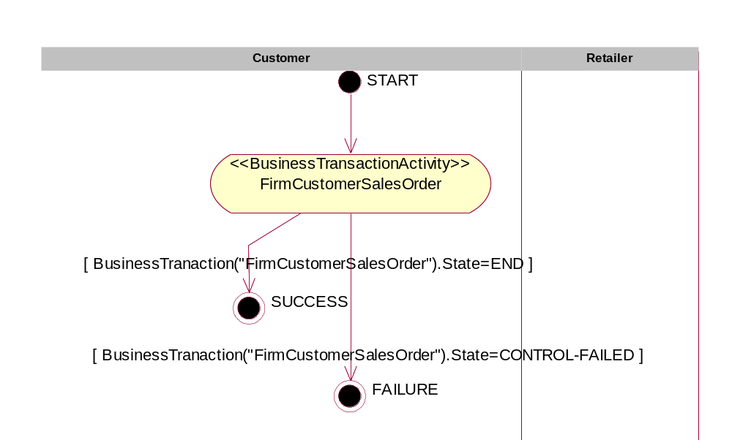
Figure 12-15, <<BusinessCollaborationProtocol>> CreateCustomerOrder
Note that in this business collaboration protocol, there is only one business transaction activity and the Customer (partner type) initiates it. The Retailer, although shown in the diagram for completeness, does not initiate any business transaction activity.

Form: Business Collaboration Protocol Table
Form Id | BCPT-7.1-Create-Customer-Order
Identifier | bcid:ean.1234567890128:CreateCustomerOrder$1.0
From Business Activity (Transaction) | Initiating Partner Type | Business Activity | Responding/ Receiving Partner Type | Transition Condition
START | Customer | Create Order | Retailer | NONE
Create Order | NOT-APPLICABLE | SUCCESS | Customer | BusinessTranaction("FirmCustomerSalesOrder").State=END ]
Create Order | NOT-APPLICABLE | FAILURE | Customer | BusinessTranaction("FirmCustomerSalesOrder").State=CONTROL-FAILED ]

    - BC-6.2-Check-Customer-Credit
Form: Business Collaboration
Form Id | BC-6.2- Check-Customer-Credit
Identifier | bcid:ean.1234567890128: CheckCustomerCredit$1.0
Partner Types | - Retailer  - Credit Authority
Authorized Roles | - Retailer  - Credit Authority Credit Service
Legal steps/requirements | None
Economic consequences | As the result of the credit check, the customer’s available credit is reduced by the total sales amount for a period of 24 hours.
Initial/terminal events | Initial - Valid customer  Terminal – Customer bad credit causes Credit Authority check to fail.
Scope | Credit Authority provides necessary information to retailer to continue processing order.
Boundary | Systems include :  - Credit Authority service.  - DSVendor customer order entry system
Constraints | None

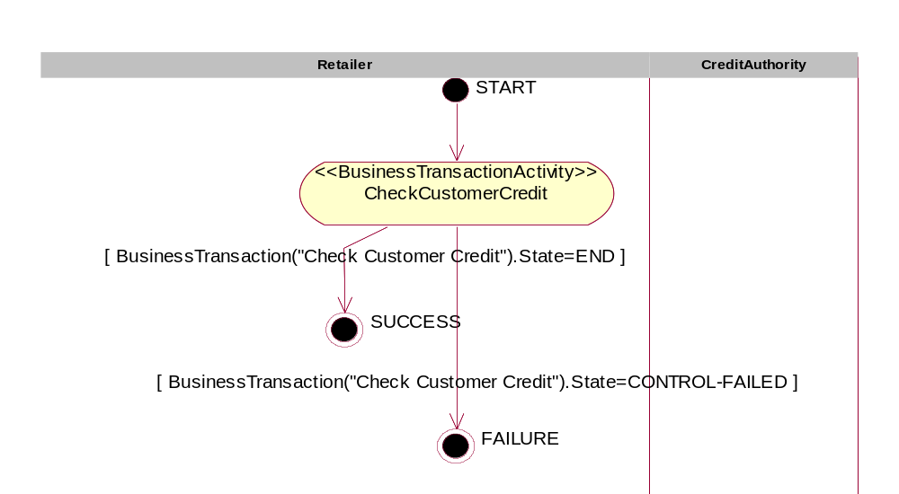
Figure 12-16, <<BusinessCollaborationProtocol>> CheckCustomerCredit
Note that there is only one initiated activity, CheckCustomerCredit, in this collaboration.

Form: Business Collaboration Protocol Table
Form Id | BCPT-7.2- Check-Customer-Credit
Identifier | bcid:ean.1234567890128:CustomerCreditCheck$1.0
From Business Activity (Transaction) | Initiating Partner Type | Business Activity | Responding/ Receiving Partner Type | Transition Condition
START | Retailer | Check Customer Credit | Credit Authority
Check Customer Credit | NOT-APPLICABLE | SUCCESS | Retailer | BusinessTransaction(“Check Customer Credit”).State=END
Check Customer Credit | NOT-APPLICABLE | FAILURE | Retailer | BusinessTransaction(“Check Customer Credit”).State=CONTROL-FAILED

    - BC-6.3-Process-Credit- Payment
Form: Business Collaboration
Form Id | BC-6.3-Process-Credit- Payment
Identifier | bcid:ean.1234567890128:ProcessCreditPayment$1.0
Partner Types | - Retailer  - Credit Authority
Authorized Roles | - Retailer.Accounts Receivable  - Credit Authority Service
Legal steps/requirements | - Sale of goods has taken place
Economic consequences | - Retailer receives payment  - Customer actually gets charged
Initial/terminal events | Initial – Products are being delivered (in-route) or have been delivered.  Terminal – Retailer receives payment
Scope | Credit Authority credits customer’s credit, only after product(s) have been shipped (or are being shipped) to customer.
Boundary | Systems include :  - Credit Authority payment system
Constraints | DSVendor must confirm that shipment of product direct to customer has taken place.

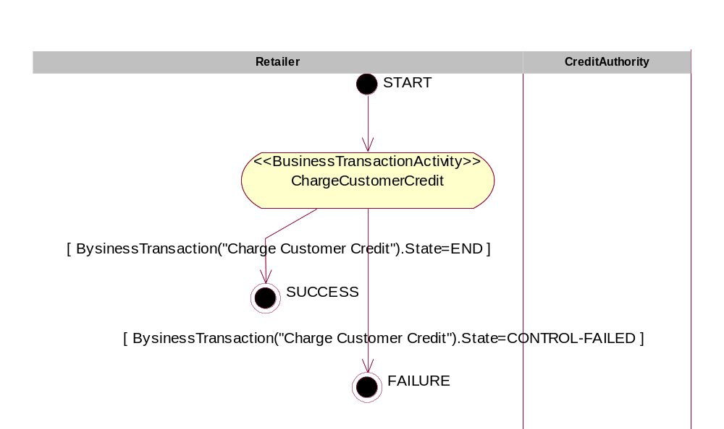
Figure 12-17, <<BusinessCollaborationProtocol>> ProcessCreditPayment
Form: Business Collaboration Protocol Table
Form Id | BCPT-7.3-Credit-Card-Payment
Identifier | bcid:ean.1234567890128:CreditCardPayment$1.0
From Business Activity (Transaction) | Initiating Partner Type | Business Activity | Responding/ Receiving Partner Type | Transition Condition
START | Retailer | Charge Customer Credit | Credit Authority | NONE
Charge Customer Credit | NOT-APPLICABLE | SUCCESS | Retailer | BysinessTransaction("Charge Customer Credit").State=END
Charge Customer Credit | NOT-APPLICABLE | FAILURE | Retailer | BysinessTransaction("Charge Customer Credit").State=CONTROL-FAILED

    - BC-6.4-Create-Vendor-Purchase-Order
Form: Business Collaboration
Form Id | BC-6.4-Create-Vendor-Purchase-Order
Identifier | bcid:ean.1234567890128:CreateVendorPurchaseOrder$1.0
Partner Types | - Retailer  - DSVendor
Authorized Roles | - Retailer.InventoryBuyer  - DSVendor.CustomerService
Legal steps/requirements | Confirmed PO Acknowledgment implies a binding agreement between Retailer and DSVendor, per conditions of an existing business relation and a specific open Purchase Order.
Economic consequences | - Intent to purchase product is made explicit  - DSVendor allocates on-hand inventory to cover PO SKU quantity for immediate direct shipment to customer
Initial/terminal events | - Valid sales order exists  - Purchase Order response
Scope | Checking DSVendor on-hand inventory to determine if a Purchase Order can be accepted or rejected.
Boundary | Systems include :  - Retailer Purchase Order Management system  - DSVendor Customer Order Entry system
Constraints | Timely response within 4 hours of submitting PO Request

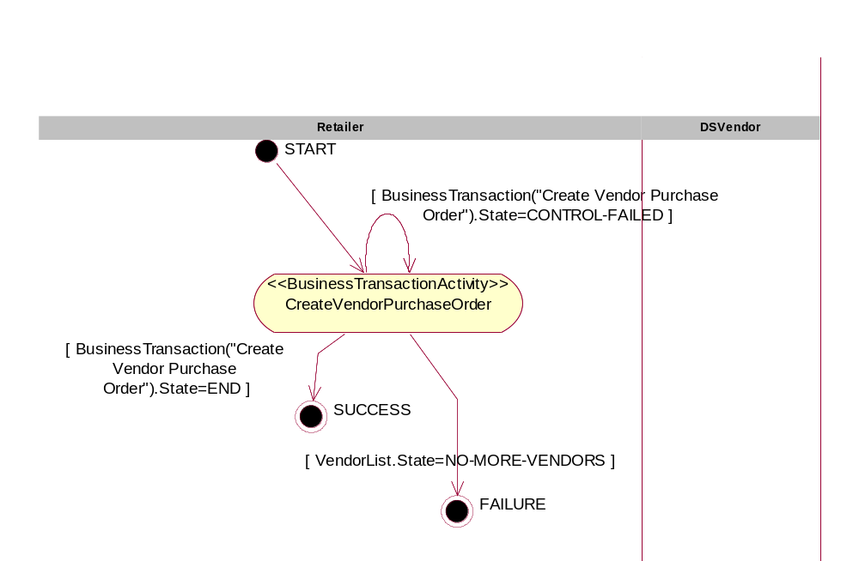
Figure 12-18 , <<BusinessCollaborationProtocol>> CreateVendorPurchaseOrder

Form: Business Collaboration Protocol Table
Form Id | BCPT-7.4-Create-Vendor-Purchase-Order
Identifier | bcid:ean.1234567890128:CreateVendorPurchaseOrder$1.0
From Business Activity (Transaction) | Initiating Partner Type | Business Activity | Responding/ Receiving Partner Type | Transition Condition
START | Retailer | Create Vendor Purchase Order | DSVendor | SalesOrder.Status=VALID
Create Vendor Purchase Order | NOT-APPLICABLE | SUCCESS | Retailer | BusinessTransaction("Create Vendor Purchase Order").State=END
Create Vendor Purchase Order | NOT-APPLICABLE | Create Vendor Purchase Order | Retailer | BusinessTransaction("Create Vendor Purchase Order").State=CONTROL-FAILED
Create Vendor Purchase Order | NOT-APPLICABLE | FAILURE | Retailer | VendorList.State=NO-MORE-VENDORS

    - BC-6.5-Shipment-Instruction
Form: Business Collaboration
Form Id | BC-6.5-Shipment-Instruction
Identifier | bcid:ean.1234567890128:ShipmentInstruction$1.0
Partner Types | - DSVendor  - Transport Carrier
Authorized Roles | - DSVendor.Shipper  - Transport Carrier.Customer Service
Legal steps/requirements | Vendor declares goods of carriage to carrier.  (note: for this example we are using domestic shipments only)
Economic consequences | None
Initial/terminal events | Initial – Successful Create Vendor Purchase Order business collaboration.  Terminal – Transport Carrier provides vendor with transport manifest.
Scope | Pertains to arrangement of physical transport per prior agreement between Retailer and Transport Carrier.
Boundary | Systems include :  - DSVendor warehouse management / transport planning system.  - Transport Carrier manifesting / Bill of Lading document management system.
Constraints | - Electronic shipment manifesting only  - Timely product pickup by transport carrier  - DSVendor must use a pre-approved Transport Carrier as specified by Retailer within Business Document details.

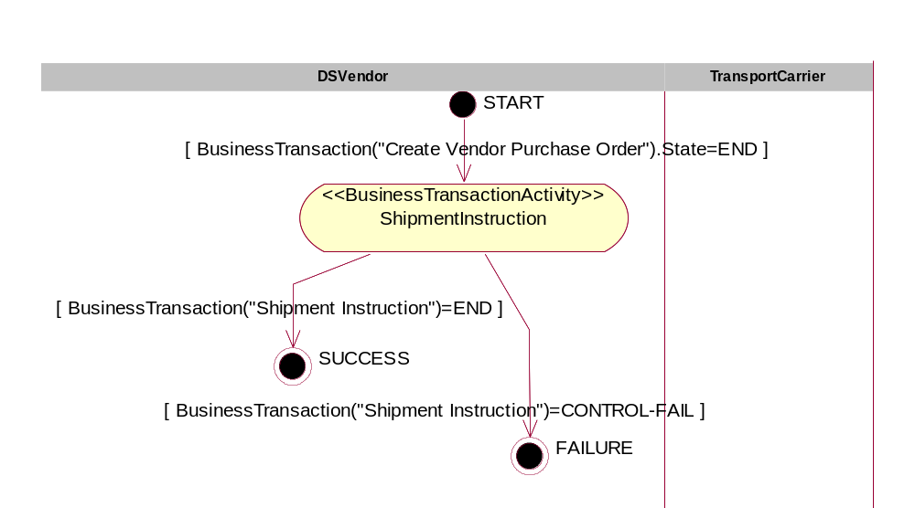
Figure 12-19, <<BusinessCollaborationProtocol>> ShipmentInstruction

Form: Business Collaboration Protocol Table
Form Id | BCPT-7.5-Shipment-Instruction
Identifier | bcid:ean.1234567890128:ShipmentInstruction$1.0
From Business Activity (Transaction) | Initiating Partner Type | Business Activity | Responding/ Receiving Partner Type | Transition Condition
START | DSVendor | ShipmentInstruction | TransportCarrier | NONE
ShipmentInstruction | NOT-APPLICABLE | SUCCESS | NOT-APPLICABLE | BusinessTransaction("Shipment Instruction")=END
ShipmentInstruction | NOT-APPLICABLE | FAILURE | NOT_APPLICABLE | BusinessTransaction(“Shipment Instruction”)=CONTROL-FAIL

    - BC-6.6-Confirm-Shipment
Form: Business Collaboration
Form Id | BC-6.6-Confirm-Shipment
Identifier | bcid:ean.1234567890128:ConfirmShipment$1.0
Partner Types | - Retailer  - DSVendor
Authorized Roles | - Retailer.Customer Service  - DSVendor.Inventory Management
Legal steps/requirements | - DSVendor declares customer shipment to Retailer  - Retailer agrees to be billed by DSVendor for original purchase price on the Purchase Order Acceptance.  - (for this scenario, DSVendor provides free shipping to customers)
Economic consequences | Point of sale between DSVendor and Retailer.
Initial/terminal events | - Initial – DSVendor notifies Retailer of shipment  - Terminal – DSVendor receives Transport Carrier shipping instruction.
Scope | Notification of customer shipment by DSVendor.
Boundary | Systems include :  - DSVendor PO Management system  - DSVendor Financial system  - DSVendor Inventory Management system  - Retailer PO Management system  - Retailer Financial system  - Retailer Customer Service Management system
Constraints | Retailer must receive Avanced Shipping Note (ASN) as confirmation of product shipment to customer in a timely fashion, and no later than 4 hours of physical product shipment from the DSVendor’s distribution point.

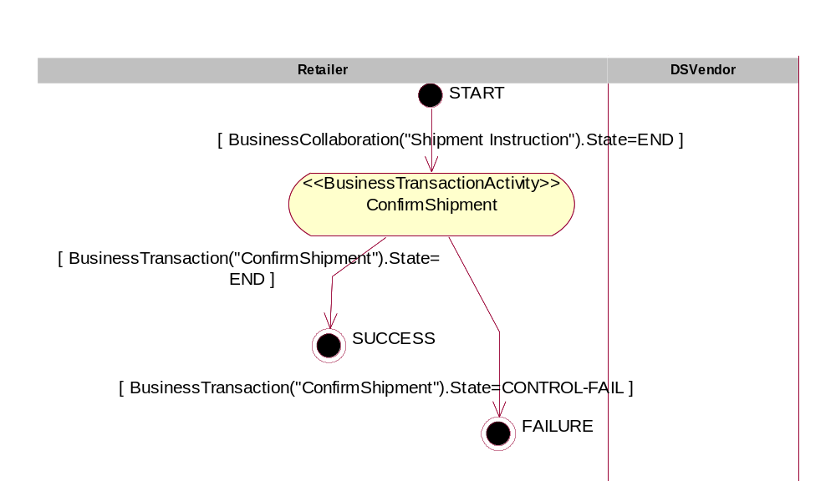
Figure 12-20, <<BusinessCollaborationProtocol>> ConfirmShipment

Form: Business Collaboration Protocol Table
Form Id | BCPT-7.6-Confirm-Shipment
Identifier | bcid:ean.1234567890128:ConfirmShipment$1.0
From Business Activity (Transaction) | Initiating Partner Type | Business Activity | Responding/ Receiving Partner Type | Transition Condition
START | Retailer | ConfirmShipment | DSVendor | NONE
ConfirmShipment | NOT-APPLICABLE | SUCCESS | NOT-APPLICABLE | BusinessTransaction(“ConfirmShipment”).State=END
ConfirmShipment | NOT-APPLICABLE | FAILURE | NOT-APPLICABLE | BusinessTransaction(“ConfirmShipment”).State=CONTROL-FAIL

    - BC-6.7-Vendor-Inventory-Reporting
Form: Business Collaboration
Form Id | BC-6.7-Vendor-Inventory-Reporting
Identifier | bcid:ean.1234567890128:VendorInventoryReporting$1.0
Partner Types | - Retailer  - DSVendor
Authorized Roles | - Retailer.Requestor  - DSVendor.Reporter
Legal steps/requirements | None
Economic consequences | None
Initial/terminal events | Initial – Inventory physically exists  Terminal – Retailer receives inventory position report.
Scope | The DSVendor is reporting a latest stage of Available to Promise but makes no warranty that when the Retailer places a PO, there will be available product to cover the PO. Rather forecasting should be used to cover at least sufficient safety stock.
Boundary | Systems include :  - Retailer inventory management systems  - DSVendor inventory / sales management systems
Constraints | Daily reporting by DSVendor. Only affected products, as a result of the Catalog Exchange process are to be reported by the DSVendor; and no other products are to be included. DSVendor reports product availability by number of SKU’s, versus a gross classification of ‘available or not available’.

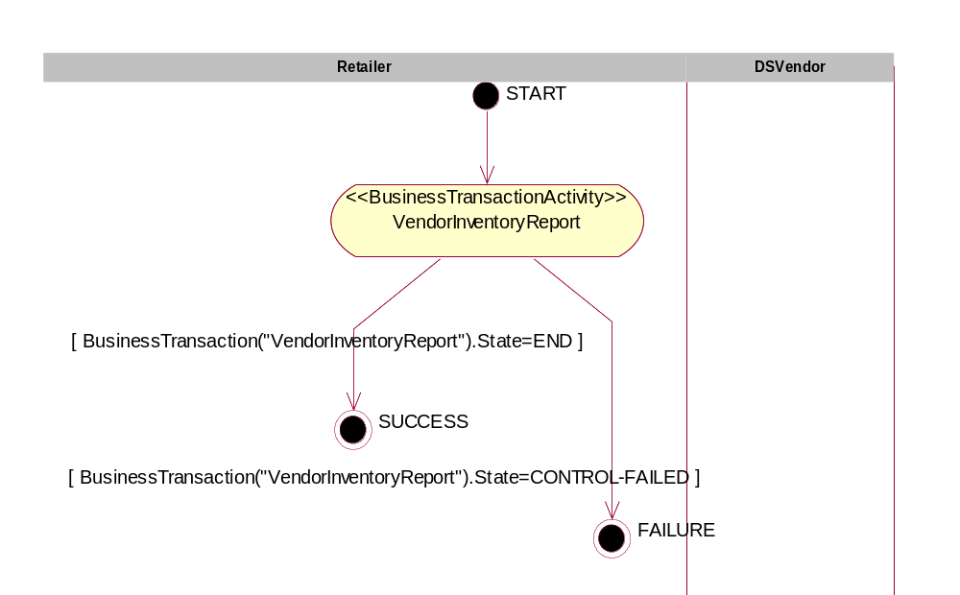
Figure 12-21, <<BusinessCollaborationProtocol>> VendorInventoryReporting
Form: Business Collaboration Protocol Table
Form Id | BCPT-7.7-Vendor-Inventory-Reporting
Identifier | bcid:ean.1234567890128:VendorInventoryReporting$1.0
From Business Activity (Transaction) | Initiating Partner Type | Business Activity | Responding/ Receiving Partner Type | Transition Condition
START | Retailer | VendorInventoryReport | DSVendor | NONE
VendorInventoryReport | NOT-APPLICABLE | SUCCESS | NOT-APPLICABLE | BusinessTransaction(“InventoryReport”).State=END
VendorInventoryReport | NOT-APPLICABLE | FAILURE | NOT-APPLICABLE | BusinessTransaction(“InventoryReport”).State=CONTROL-FAILED

    - BC-6.8-Request-Inventory-Report
Form: Business Collaboration
Form Id | BC-6.8-Request-Inventory-Report
Identifier | bcid:ean.1234567890128:RequestInventoryReport$1.0
Partner Types | - Retailer  - DSVendor
Authorized Roles | - Retailer.Inventory Management  - DSVendor.Inventory / Customer Service Management
Legal steps/requirements | None
Economic consequences | None
Initial/terminal events | See BC-6.7-Vendor-Inventory-Management
Scope | See BC-6.7-Vendor-Inventory-Management
Boundary | See BC-6.7-Vendor-Inventory-Management
Constraints | See BC-6.7-Vendor-Inventory-Management

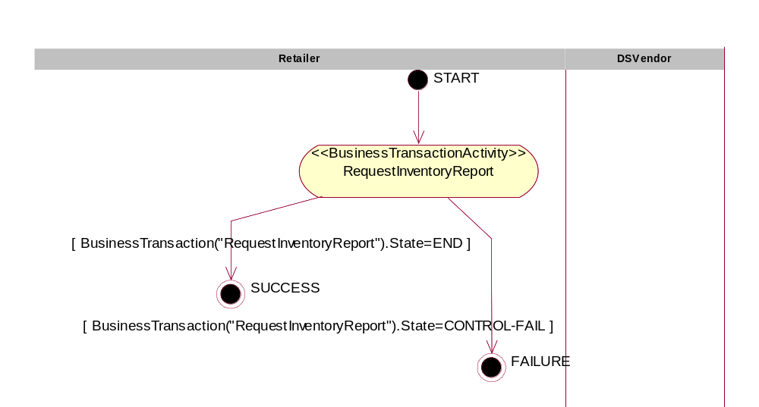
Figure 12-22, <<BusinessCollaborationProtocol>> RequestInventoryReport
Form: Business Collaboration Protocol Table
Form Id | BCPT-7.8-Request-Inventory-Report
Identifier | bcid:ean.1234567890128:RequestInventoryReport$1.0
From Business Activity (Transaction) | Initiating Partner Type | Business Activity | Responding/ Receiving Partner Type | Transition Condition
START | Retailer | RequestInventoryReport | DSVendor | NONE
RequestInventoryReport | NOT-APPLICABLE | SUCCESS | NOT-APPLICABLE | BusinessTransaction(“RequestInventoryReport”).State=END
RequestInventoryReport | NOT-APPLICABLE | FAILURE | NOT-APPLICABLE | BusinessTransaction(“RequestInventoryReport”).State=CONTROL-FAIL

    - BC-6.9-Sales-Product-Offering
Form: Business Collaboration
Form Id | BC-6.9-Sales-Product-Offering
Identifier | bcid:ean.1234567890128:SalesProductOffering$1.0
Partner Types | - DSVendor  - Retailer
Authorized Roles | - Retailer.Merchandising  - DSVendor.Sales
Legal steps/requirements | DSVendor warrants that products offered for consumer sale are valid and legal.
Economic consequences | None, unless prior business agreements of minimum sales quantities are applicable.
Initial/terminal events | Initial – DSVendor sends Retailer valid product specifications  Terminal – Retailer receives valid product specifications.
Scope | At start of a relationship, the DSVendor will offer a full list of all products that may be offered for consumer sale by the Retailer.
Boundary | Systems include :  - DSVendor inventory management systems  - Retailer inventory management systems
Constraints | Only products intended for consumer resale are offered by the DSVendor to the Retailer. (i.e. No spamming the Retailer).

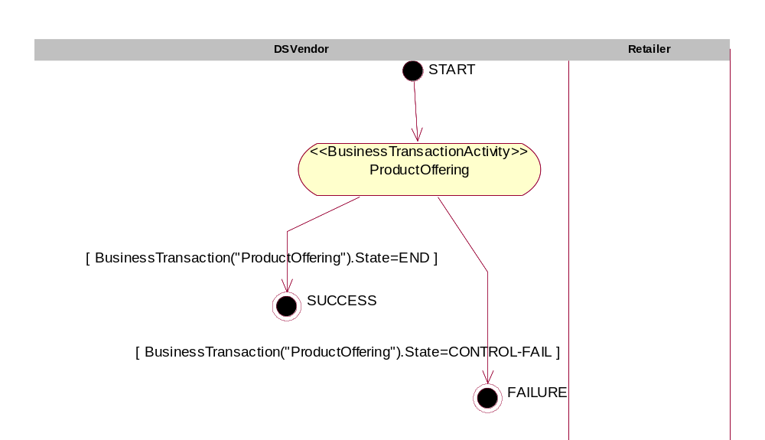
Figure 12-23, <<BusinessCollaborationProtocol>> SalesProductOffering
Form: Business Collaboration Protocol Table
Form Id | BCPT-7.9-Sales-Product-Offering
Identifier | bcid:ean.1234567890128:SalesProductOffering$1.0
From Business Activity (Transaction) | Initiating Partner Type | Business Activity | Responding/ Receiving Partner Type | Transition Condition
START | DSVendor | ProductOffering | Retailer | NONE
ProductOffering | NOT-APPLICABLE | SUCCESS | NOT-APPLICABLE | BusinessTransaction(“ProductOffering”).State=END
ProductOffering | NOT-APPLICABLE | FAILURE | NOT-APPLICABLE | BusinessTransaction(“ProductOffering”).State=CONTROL-FAIL

    - BC-6.10-Invoice-Presentment
Form: Business Collaboration
Form Id | BC-6.10-Invoice-Presentment
Identifier | bcid:ean.1234567890128:InvoicePresentment$1.0
Partner Types | - DSVendor  - Retailer
Authorized Roles | - Retailer.ProcessPayment  - DSVendor.ProcessPayment
Legal steps/requirements
Economic consequences
Initial/terminal events
Scope
Boundary
Constraints

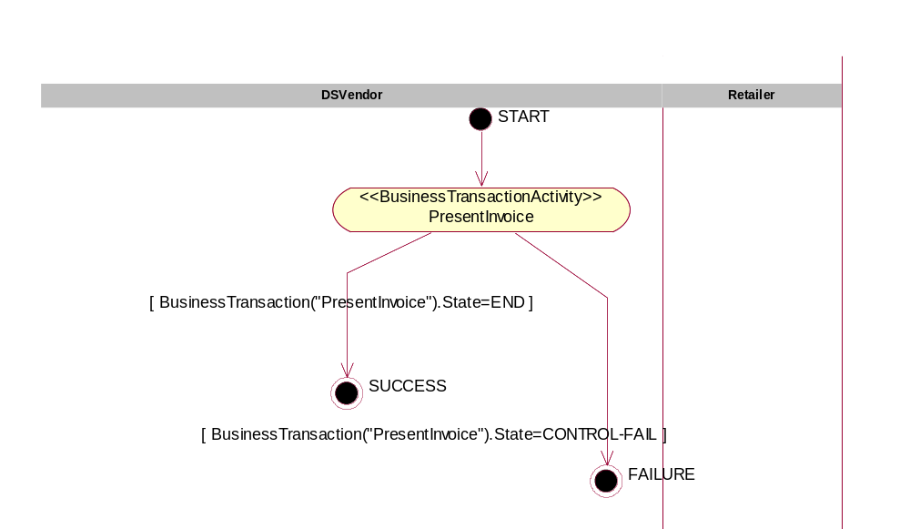
Figure 12-24, <<BusinessCollaborationProtocol>> InvoicePresentment
Form: Business Collaboration Protocol Table
Form Id | BCPT-7.10-Invoice-Presentment
Identifier | bcid:ean.1234567890128:InvoicePresentment$1.0
From Business Activity (Transaction) | Initiating Partner Type | Business Activity | Responding/ Receiving Partner Type | Transition Condition
START | DSVendor | Present Invoice | Retailer | NONE
Present Invoice | DSVendor | SUCCESS | NOT-APPLICABLE | BusinessTransaction(“PresentInvoice”).State=END
Present Invoice | DSVendor | FAILURE | NOT-APPLICABLE | BusinessTransaction(“PresentInvoice”).State=CONTROL-FAIL

  - Business Transactions and Authorized Roles
    - BT-8.1-Firm-Customer-Sales-Order
Form: Business Transaction
Form Id | BT-8.1-Firm-Customer-Sales-Order
Identifier | btid:ean.1234567890128:FirmCustomerSalesOrder$1.0
Description | Register customer demand for specific product to be fulfilled.
Pattern | Business Transaction
Business activities and associated authorized roles
Constraints | - Valid Customer  - Valid Product  - Valid Vendor
Requesting Partner Type | Customer
Requesting Activity Role | Buying Customer
Requesting Activity Document | Sales Order
Responding Partner Type | Retailer
Responding Activity Role | Customer Service
Responding Activity Document | Confirmation email
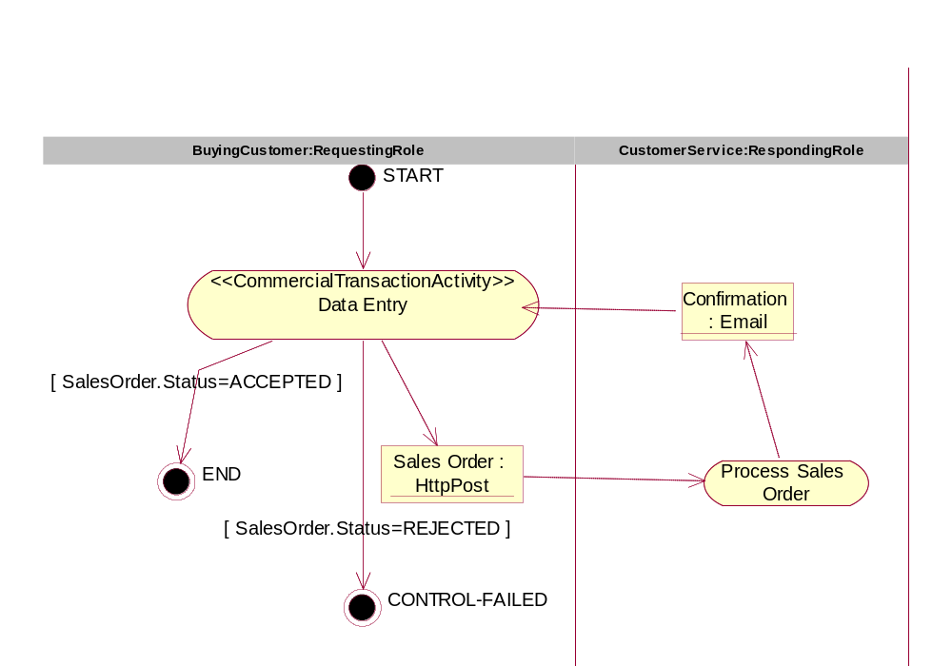
Figure 12-25, <<BusinessTransaction>> FirmCustomerSalesOrder

    - BT-8.2-Check Customer Credit
Form: Business Transaction
Form Id | BT-8.2-Check Customer Credit
Identifier | btid:ean.1234567890128:CheckCustomerCredit$1.0
Description | With complete customer details, including a total sales amount, check the customer’s credit ability to eventually pay for product once drop shipped from the vendor.
Pattern | Request/Response
Business activities and associated authorized roles | See BTTT-8.2- Check-Customer-Credit
Constraints | - Valid business agreement with vendor  - Valid customer details
Requesting Partner Type | Retailer
Requesting Activity Role | Customer Service
Requesting Activity Document | Credit Check (typically a proprietary document)
Responding Partner Type | Credit Authority
Responding Activity Role | Credit Service
Responding Activity Document | Credit Check Response

Form: Business Transaction Transition Table
Form Id | BTTT-8.2- Check-Customer-Credit
From Activity | From Role | Document | To Activity | To Role | Guard Condition
START | NOT-APPLICABLE | NONE | Request Check Credit | Retailer.CustomerService | NONE
Request Check Credit | Retailer.CustomerService | Credit Check Request | Process Credit Check | CreditAuthority.CreditService | NONE
Process Credit Check | CreditAuthority.CreditService | Credit Check Response | Request Check Credit | Retailer.CustomerService | NONE
Request Check Credit | Retailer.CustomerService | NONE | END | NOT-APPLICABLE | CreditCheckResponse.Status=GOOD-CREDIT
Request Check Credit | Retailer.CustomerService | NONE | CONTROL-FAILED | NOT-APPLICABLE | CreditCheckResponse.Status=BAD-CREDIT

    - BT-8.3-Charge-Customer-Credit
Form: Business Transaction
Form Id | BT-8.3-Charge-Customer-Credit
Identifier | btid:ean.1234567890128:ChargeCustomerCredit$1.0
Description | Given all customer details, plus total sales amount based on product actually shipped by DSVendor, do a charge on the customer’s credit.
Pattern | Business Transaction
Business activities and associated authorized roles | See BTTT-8.3-Charge-Customer-Credit
Constraints | Valid sales order  Confirmed Shipped product
Initiating/Requesting Partner Type | Retailer
Initiating/Requesting Activity Role | Accounts Receivable
Initiating/Requesting Document | Charge Credit Request
Responding Partner Type | Credit Authority
Responding Activity Role | Credit Authority Service
Responding Document | Charge Credit Response

Form: Business Transaction Transition Table
Form Id | BTTT-8.3-Charge-Customer-Credit
From Activity | From Role | Document | To Activity | To Role | Guard Condition
START | N/A | N/A | RequestCreditCharge | Retail.ChargeCredit | NONE
RequestCreditCharge | Retail.ChargeCredit | ChargeCredit | ProcessCreditCharge | CreditAuthority.CreditService | NONE
ProcessCreditCharge | CreditAuthority.CreditService | ConfirmCredit | RequestCreditCharge | Retail.ChargeCredit | NONE
RequestCreditCharge | Retail.ChargeCredit | N/A | END | N/A | Message(ConfirmCredit).Status =RECEIVED
RequestCreditCharge | Retail.ChargeCredit | N/A | CONTROL-FAILED | N/A | Message(ConfirmCredit).Status =NOT-RECEIVED

    - BT-8.4-Create-Vendor-Purchase-Order
Form: Business Transaction
Form Id | BT-8.4-Create-Vendor-Purchase-Order
Identifier | btid:ean.1234567890128:FirmCustomerSalesOrder$1.0
Description | Given a multi-vendor / single product relationship, Retailer needs to send a DSVendor a Purchase Order REQUEST, which will need to be responded back (with confirmed allocated product to cover the PO) by the DSVendor.
Pattern | Business Transaction
Business activities and associated authorized roles | See BTTT-8.4-Create-Vendor-Purchase-Order
Constraints | Valid Sales order  Valid customer credit check
Requesting Partner Type | Retailer
Requesting Activity Role | Inventory Buyer
Requesting Activity Document | Purchase Order Request
Responding Partner Type | DSVendor
Responding Activity Role | Seller
Responding Activity Document | Purchase Order Acknowledgement

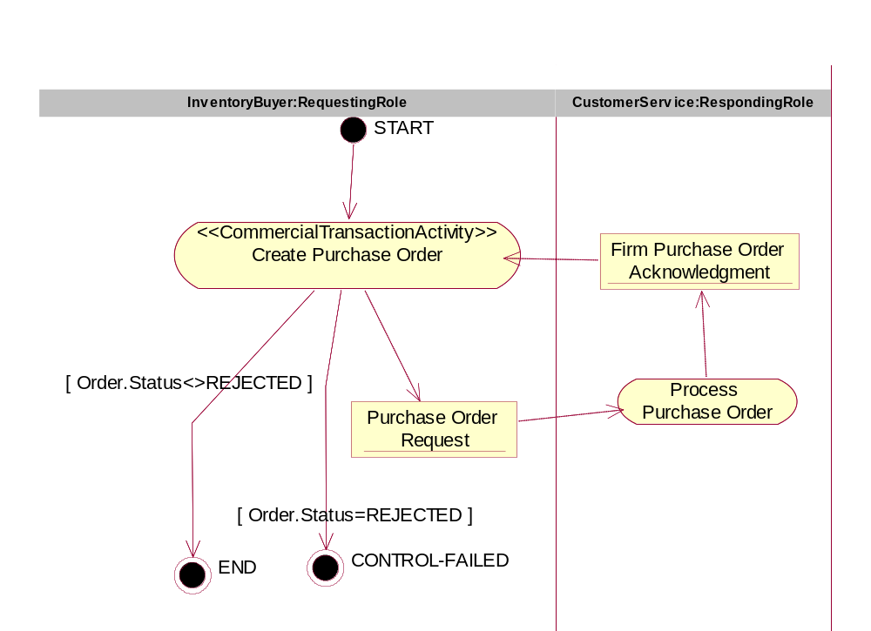
Figure 12-26, <<BusinessTransaction>> PurchaseOrderRequest

Form: Business Transaction Transition Table
Form Id | BTTT-8.4-Create-Vendor-Purchase-Order
From Activity | From Role | Document | To Activity | To Role | Guard Condition
START | N/A | N/A | Create Purchase Order | InventoryBuyer | NONE
Create Purchase Order | InventoryBuyer | Purchase Order Request | Process Purchase Order | CustomerService | NONE
Process Purchase Order | CustomerService | Firm Purchase Order Acknowledgement | Create Purchase Order | InventoryBuyer | NONE
Create Purchase Order | InventoryBuyer | N/A | END | N/A | Order.Status<>REJECTED
Create Purchase Order | InventoryBuyer | N/A | CONTROL-FAILED | N/A | Order.Status=REJECTED

    - BT-8.5-Vendor-Inventory-Report
Form: Business Transaction
Form Id | BT-8.5-Vendor-Inventory-Report
Identifier | btid:ean.1234567890128:VendorInventoryReport$1.0
Description | Regular periodic notification, unsolicited, from the DSVendor to the Retailer, containing Available to Promise On-Hand inventory.
Pattern | Notification
Business activities and associated authorized roles | See BTTT-8.5-Vendor-Inventory-Report
Constraints | Only send product inventory which has been agreed to be made consumer available per agreement from the Product Catalog Exchange negotiation pattern.
Initiating/Requesting Partner Type | DSVendor
Initiating/Requesting Activity Role | Inventory Buyer
Initiating/Requesting Activity Document | Inventory Report
Responding Partner Type | Retailer
Responding Activity Role | Inventory Buyer
Responding Activity Document

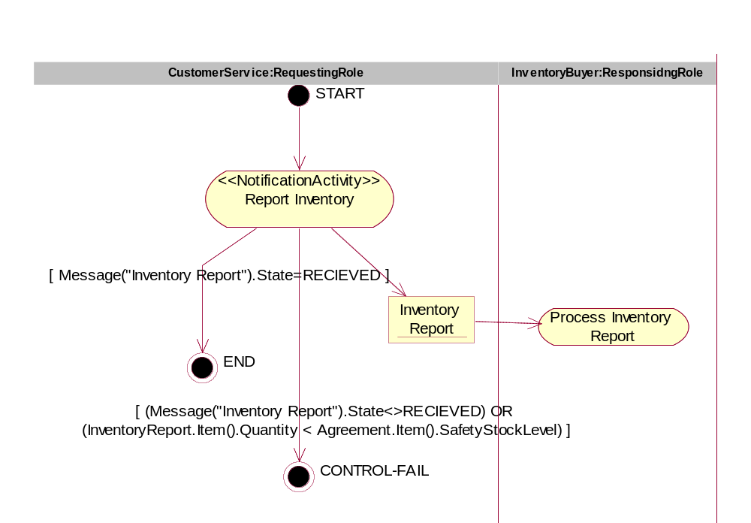
Figure 12-27, <<BusinessTransaction>> VendorInventoryReport

Form: Business Transaction Transition Table
Form Id | BTTT-8.5-Vendor-Inventory-Report
From Activity | From Role | Document | To Activity | To Role | Guard Condition
START | NOT-APPLICABLE | NONE | Report Inventory | DSVendor.CustomerService | NONE
Report Inventory | DSVendor.CustomerService | Inventory Report | Process Inventory Report | Retailer.InventoryBuyer | NONE
Report Inventory | DSVendor.CustomerService | NONE | END | N/A | Message(“Inventory Report”).State=RECIEVED
Report Inventory | DSVendor.CustomerService | NONE | CONTROL-FAILED | N/A | Message(“Inventory Report”).State<>RECEIVED OR InventoryReport..Item().Quatntity<Agreement.Item().SafteyStockLevel

    - BT-8.6-Request-Inventory-Report
Form: Business Transaction
Form Id | BT-8.6-Request-Inventory-Report
Identifier | btid:ean.1234567890128:RequestInventoryReport$1.0
Description | Query Response dialogue where the Retailer requests the DSVendor for the current Avaialable to Promise position of a product; or series of products.
Pattern | Query / Response (per UMM pattern specirfications)
Business activities and associated authorized roles | See BTTT-8.6-Request-Inventory-Report
Constraints | See BT-8.5-Vendor-Inventory-Report
Requesting Partner Type | Retailer
Requesting Activity Role | Inventory Buyer
Requesting Activity Document | On-hand Available to Promise Product Availability Request
Responding Partner Type | DSVendor
Responding Activity Role | Customer Service
Responding Activity Document | on-hand Available to Promise report

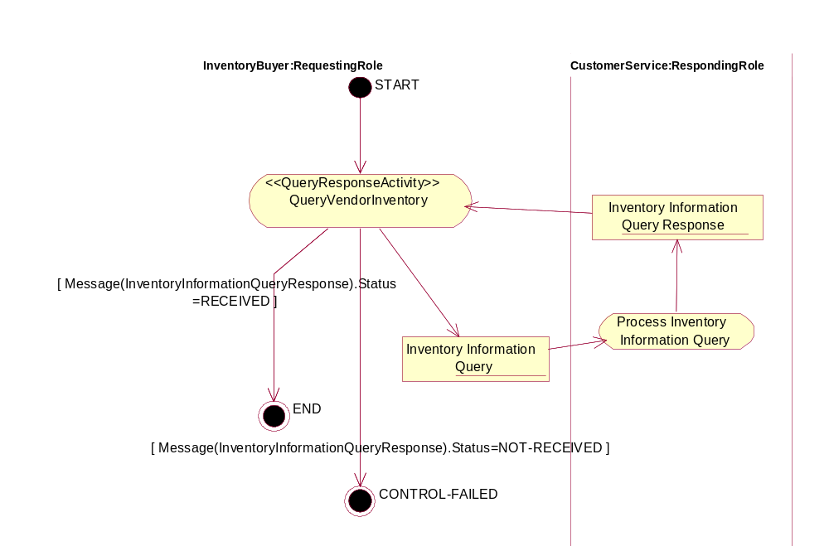
Figure 12-28, <<BusinessTransaction>> RequestInventoryReport

Form: Business Transaction Transition Table
Form Id | BTTT-8.6-Request-Inventory-Report
From Activity | From Role | Document | To Activity | To Role | Guard Condition
START | N/A | N/A | QueryVendorInventory | InventoryBuyer | NONE
QueryVendorInventory | InventoryBuyer | Inventory Information Query | Process Inventory Information Query | CustomerService | NONE
Process Inventory Information Query | CustomerService | Inventory Information Query Response | QueryVendorInventory | InventoryBuyer | NONE
QueryVendorInventory | InventoryBuyer | N/A | END | N/A | Message(InventoryInformationQueryResponse).Status =RECEIVED
QueryVendorInventory | InventoryBuyer | N/A | CONTROL-FAILED | N/A | Message(InventoryInformationQueryResponse).Status =NOT-RECEIVED

    - BT-8.7-Shipment-Notification
Form: Business Transaction
Form Id | BT-8.7-Shipment-Notification
Identifier | btid:ean.1234567890128:FirmCustomerSalesOrder$1.0
Description | Arrangement of carriage by the DSVendor towards a Transport Carrier; who is expected to physically ship the product direct to the Customer.
Pattern | Business Transaction
Business activities and associated authorized roles | See BTTT-8.7-Shipment-Notification
Constraints | Customer Ship To details must be accurate
Requesting Partner Type | DSVendor
Requesting Activity Role | Shipper
Requesting Activity Document | Shipment Instruction (UN/CEFACT EDIFACT IFTMIN D01)
Responding Partner Type | Transport Carrier
Responding Activity Role | Customer Service
Responding Activity Document | Electronic copy of a Bill of Lading (UN/CEFACT EDIFACT IFTMCS D01)

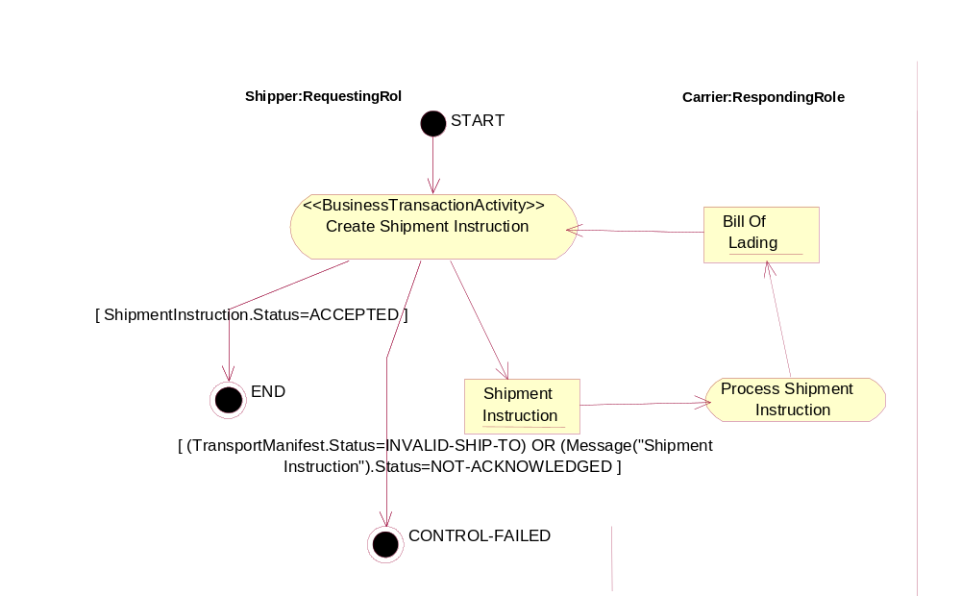
Figure 12-29, <<BusinessTransaction>> ShipmentInstruction

Form: Business Transaction Transition Table
Form Id | BTTT-8.7-Shipment-Notification
From Activity | From Role | Document | To Activity | To Role | Guard Condition
START | NOT-APPLICABLE | NONE | Prepare Shipping Instruction | DSVendor.Shipper | NONE
Prepare Shipping Instruction | DSVendor.Shipper | Shipment Instruction | Process Shipment Instruction | TransportCarrier.CustomerService | NONE
Process Shipment Instruction | TransportCarrier.CustomerService | Bill Of Lading | Process Shipment Instruction | DSVendor.Shipper | NONE
Process Shipment Instruction | DSVendor.Shipper | NONE | END | NOT-APPLICABLE | Message(“Bill Of Lading”).State=RECIEVED
Process Shipment Instruction | DSVendor.Shipper | NONE | CONTROL-FAILED | NOT-APPLICABLE | Message(“Bill Of Lading”).State<>RECEIVED

    - BT-8.8-Confirm-Shipment
Form: Business Transaction
Form Id | BT-8.8-Confirm-Shipment
Identifier | btid:ean.1234567890128:FirmCustomerSalesOrder$1.0
Description | DSVendor informs the Retailer that the Customer’s product has been shipped to the Customer; and thus the conditions of the PO have been fulfilled.
Pattern | Notification
Business activities and associated authorized roles | See BTTT-8.8-Confirm-Shipment
Constraints | - Product must actually be shipped  - DSVendor must return a Transport Carrier tracking number; for customer service.
Requesting Partner Type | DSVendor
Requesting Activity Role | Shipper
Requesting Activity Document | Advance Ship Notice (UN/CEFACT EDIFACT DESADV D01)
Responding Partner Type | Retailer
Responding Activity Role | Customer Service
Responding Activity Document | NONE

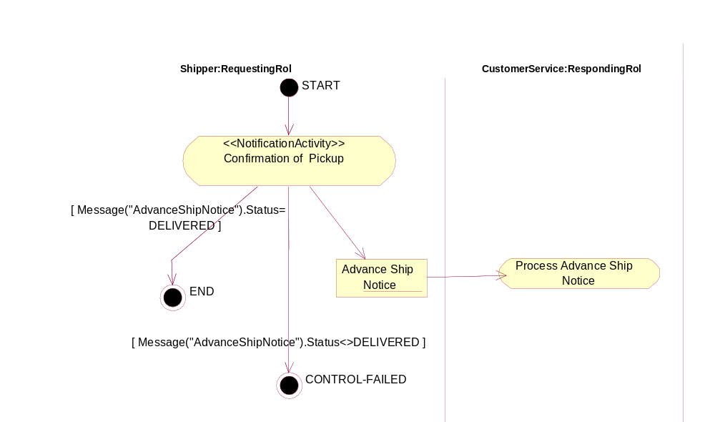
Figure 12-30, <<BusinessTransaction>> ConfirmShipment

Form: Business Transaction Transition Table
Form Id | BTTT-8.8-Confirm-Shipment
From Activity | From Role | Document | To Activity | To Role | Guard Condition
START | NOT-APPLICABLE | NONE | Confirmation of Pickup | Shipper | NONE
Confirmation of Pickup | Shipper | Advance Ship Notice | Process Advance Ship Notice | Retailer.CustomerService | NONE
Confirmation of Pickup | Shipper | NONE | END | NOT-APPLICABLE | Message(“Advance Ship Notice”).State=RECEIVED
Confirmation of Pickup | Shipper | NONE | CONTROL-FAILED | NOT-APPLICABLE | Message(“Advance Ship Notice”).State<>RECEIVED

    - BT-8.9-Product-Offering
Form: Business Transaction
Form Id | BT-8.9-Product-Offering
Identifier | btid:ean.1234567890128:ProductOffering$1.0
Description | DSVendor offers product details to the Retailer, where the Retailer is expected to either accept the DSVendor’s product for consumer sale or reject the product; perhaps because of unacceptable product terms and conditions.
Pattern | Request / Confirm
Business activities and associated authorized roles | See BTTT-8.9-Product-Offering
Constraints | Valid products for consumer sale by Retailer
Requesting Partner Type | DSVendor
Requesting Activity Role | Catalog Publishing
Requesting Activity Document | Product Catalog Offering (ANSI X.12 832 4010 version)
Responding Partner Type | Retailer
Responding Activity Role | Merchandising
Responding Activity Document | Product Catalog Acceptance (often proprietary format response document)

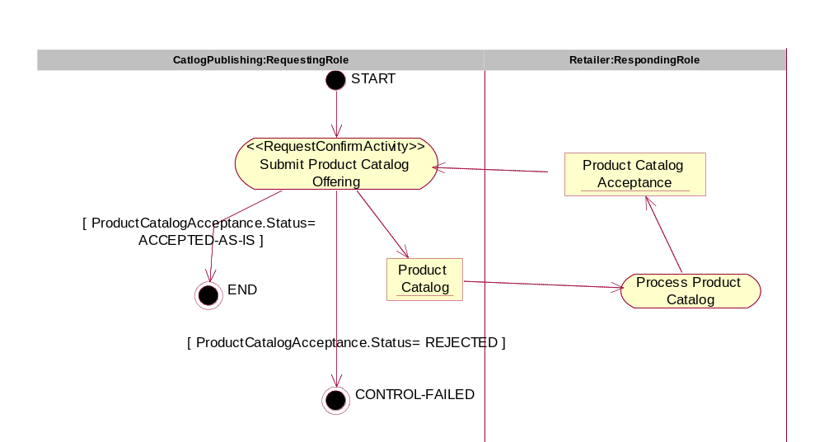
Figure 12-31, <<BusinessTransaction>> ProductOffering

Form: Business Transaction Transition Table
Form Id | BTTT-8.9-Product-Offering
From Activity | From Role | Document | To Activity | To Role | Guard Condition
START | NOT-APPLICABLE | NONE | Submit Product Catalog Offering | CatalogPublishing | NONE
Submit Product Catalog Offering | CatalogPublishing | Product Catalog | Process Product Catalog | Retailer.Merchandising | NONE
Process Product Catalog | Retailer.Merchandising | Product Catalog Acceptance | Submit Product Catalog Offering | CatalogPublishing | NONE
Submit Product Catalog Offering | CatalogPublishing | NONE | END | NOT-APPLICABLE | ProductCatalogAcceptance.Status=ACCEPTED-AS-IS
Submit Product Catalog Offering | CatalogPublishing | NONE | CONTROL-FAILED | NOT-APPLICABLE | ProductCatalogAcceptance.Status=REJECTED

    - BT-8.10-Present-Invoice
Form: Business Transaction
Form Id | BT-8.10-Present-Invoice
Identifier | btid:ean.1234567890128:PresentInvoice$1.0
Description | This is the vendor’s invoice to the retailer for products and services shipped to customer.
Pattern | Notification
Business activities and associated authorized roles | See BTTT-8.10-Present-Invoice
Constraints | - The invoice shall only be sent after confirmed shipment  - The invoice shall reflect the confirmed shipment
Requesting Partner Type | DSVendor
Requesting Activity Role | Payee
Requesting Activity Document | Invoice
Responding Partner Type | Retailer
Responding Activity Role | Payor
Responding Activity Document | NONE

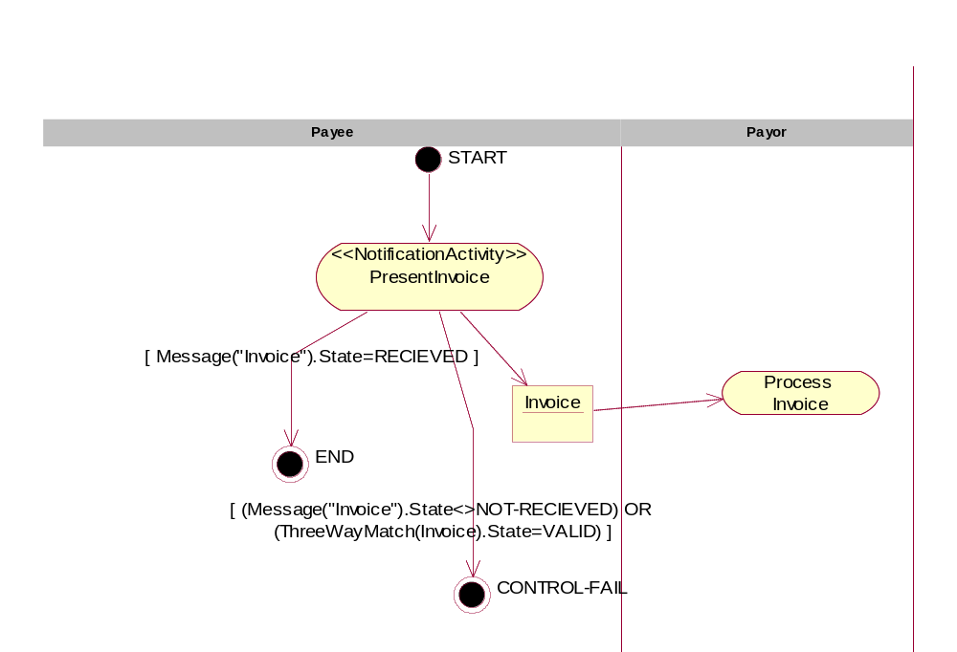
Figure 12-32, <<BusinessTransaction>> PresentInvoice

Form: Business Transaction Transition Table
Form Id | BTTT-8.10-Present-Invoice
From Activity | From Role | Document | To Activity | To Role | Guard Condition
START | NOT-APPLICABLE | NONE | Present Invoice | Payee | NONE
Present Invoice | Payee | Invoice | Process Invoice | Payor | NONE
Present Invoice | Payee | NONE | END | NOT-APPLICABLE | Message(“Invoice”).State=RECEIVED
Present Invoice | Payee | NONE | CONTROL-FAILED | NOT-APPLICABLE | Message(“Invoice”).State<>RECEIVED OR ThreeWayMatach(Invoice).State=VALID

  - Business Information Description
    - Purchase Order
      - Purchase Order Business Information Context
Form: Business Information Context
Form Id: | BIC-10.1-Purchase-Order
Industry Segment | Retail
Business Process | BPUC-5.4-Purchase-Order-Management  BC-8.4-Create-Vendor-Purchase-Order  BT-8.4-Create-Vendor-Purchase-Order
Product | NOT-APPLICABLE
Physical Geography /Conditions /Region | North America
Geo-Political Legislative/ Regulatory/ Cultural | NOT-APPLICABLE
Application Processing | NOT-APPLICABLE
Business Purpose /Domain | See BPUC-5.4-Purchase-Order-Management
Partner Role | Inventory Buyer  Customer Service
Service Level (profiles – not preferences.) | NOT-APPLICABLE
Contracts/Agreements | “My Business Agreement With My Vendor”

      - CD-9.1-Order
Form: Content Description
Form Id: | CD-9.1-Order
Element/Component Name |  | Occurs | Data Type | Field Width | Semantic Description | Notes
Order Header |  | 1 |  | N/A | The Order Header contains the header information of the order
Order Detail |  | 0..1 |  | N/A | The Order Detail contains the line item and package details of the Order.
Order Summary |  | 0..1 |  | N/A | The Order Summary contains the summary information of the order, typically totals of numerical fields

      - CD-#.#-Order-Summary
Form: Content Description
Form Id: | CD-9.2-Order-Summary
Element/Component Name |  | Occurs | Data Type | Field Width | Semantic Description | Notes
Number Of Lines |  | 0..1 | Integer |  | Number Of Lines identifies the number of line items.
Total Tax |  | 0..1 | Monetary Value | N/A | Total Tax contains the total tax amount for the Order.
Total Amount |  | 0..1 | Monetary Value | N/A | Total Amount contains the total price for the entire Order.
Transport Packaging Totals |  | 0..1 |  |  | Transport Packaging Totals is a summary of transport and packaging information if included in the Order.
Summary Note |  | 0..1 | String |  | Summary Note contains any free form text for the Order Summary. This element may contain notes or any other similar information that is not contained explicitly in the another structure. You should not assume that the receiving application is capable of doing more than storing and/or displaying this information

    - Content Mapping
[If we feel so ambitious, we can use the ANSI X12 4010 mappings available at http://www.xcbl.org/xcbl30/Mapping/smg.html]
These forms SHOULD be completed. This information is very important as it shows that the documents have a basis in existing standards. Furthermore, the information will be used to create document transformations. Standards to map to include EDIFACT, X12, xCBL, RosettaNet, and other standards such as OBI. Use XPATH and XSLT notation for referencing XML elements and describing the mappings. If a new document schema is created to fulfil the content requirements specified in the Document Content Description forms, then a set of Content Mapping forms should be completed for that schema (the component names in the forms are simply requirements for information)
For each Content Description form, complete a Document Content Mapping form for each standard to be cross-referenced.
      - CM-11.1-Order-Summary
Form: Content Mapping
Form Id: |  | CM-11.1-Order-Summary
Content Description Form Id |  | CD-11.1-Order-Summary
Standard |  | ANSI X12 850
Version |  | 4010
Element/Component Name | Mapping/Transformation |  | Note
Number Of Lines | 850:S:CTT:010:CTT:01:354:
Total Tax | NOT USED
Total Amount | Various (850:S:CTT:020:AMT:02:782:, etc.) |  | Total amount is a complex structure that includes things like reference currency, target currency, and rate of exchange. For an example mapping see xCBL.org). Do mapping in a separate table.
Transport Packaging Totals | Various |  | Transport packing totals is a complex structure. Do mapping in a separate table.
Summary Note | 850:S:CTT:010:CTT:02:347:

- Disclaimer
The views and specification expressed in this document are those of the authors and are not necessarily those of their employers. The authors and their employers specifically disclaim responsibility for any problems arising from correct or incorrect implementation or use of this design.
- Contact Information
Business Process Project Team
Core Components/Business Process (CC/BP) Analysis Team Lead
Name: Brian Hayes
Company: Commerce One
Street: 4440 Rosewood Drive
City, State, ZIP/Other: Pleasanton, CA
Nation: USA
Phone: +1 (925) 788-6304
EMail: brian.hayes@UCLAlumni.net

Editors

Name: Charles Fineman
Company: Arzoon
Street: 1950 Elkhorn Court
City, State, ZIP/Other: San Mateo, CA 94403
Phone: +1 (650) 357-6052
EMail: fineman@arzoon

Name: Brian Hayes
Company: Commerce One
Street: 4440 Rosewood Drive
City, State, ZIP/Other: Pleasanton, CA
Nation: USA
Phone: +1 (925) 788-6304
EMail: brian.hayes@UCLAlumni.net

Name: Jennifer Loveridge
Company: Nordstrom.com
Street: 600 University Street, Ste. 600
City, State, ZIP/Other: Seattle, WA
Nation: USA
Phone:
EMail: Jennifer.Loveridge@Nordstrom.com

Name: William E. McCarthy
University: Michigan State University
Street: N270 North Business Complex
City, State, ZIP/Other: East Lansing, MI
Nation: USA
Phone: +1 (517) 432-2913
EMail: mccarth4@msu.edu

Name: David Welsh
Company: Nordstrom.com
Street: 600 University Street, Ste. 600
City, State, ZIP/Other: Seattle, WA
Nation: USA
Phone: +1 (206) 215-7293
EMail: David.Welsh@Nordstrom.com
Copyright Statement
Copyright © UN/CEFACT and OASIS, 2001. All Rights Reserved.
This document and translations of it may be copied and furnished to others, and derivative works that comment on or otherwise explain it or assist in its implementation may be prepared, copied, published and distributed, in whole or in part, without restriction of any kind, provided that the above copyright notice and this paragraph are included on all such copies and derivative works. However, this document itself may not be modified in any way, such as by removing the copyright notice or references to ebXML, UN/CEFACT, or OASIS, except as required to translate it into languages other than English.
The limited permissions granted above are perpetual and will not be revoked by ebXML or its successors or assigns. This document and the information contained herein is provided on an "AS IS" basis and ebXML DISCLAIMS ALL WARRANTIES, EXPRESS OR IMPLIED, INCLUDING BUT NOT LIMITED TO ANY WARRANTY THAT THE USE OF THE INFORMATION HEREIN WILL NOT INFRINGE ANY RIGHTS OR ANY IMPLIED WARRANTIES OF MERCHANTABILITY OR FITNESS FOR A PARTICULAR PURPOSE.

A group of ebXML contributors are working on a prototype of an editor that uses wizards to guide the user through the construction of a UMM compliant Business Process.
A template is a document or file having a preset format that is used as a starting point for developing human-readable versions of the business process specifications so that the format does not have to be recreated each time it is used.
Defines plan, source, make and deliver business areas in their Supply Chain Operations Reference (SCOR) model
Worksheets will be made available in a future version of this document.
There has been discussion on private vs. public repositories where some or all aspects of the model are stored in a restricted access repository.
See chapter 4 in [UMM].
Cref [ebRIM] and [ebRS].
DSVendor.Shipper may get an emial or phone calls stating that the goods will not be shipped.

